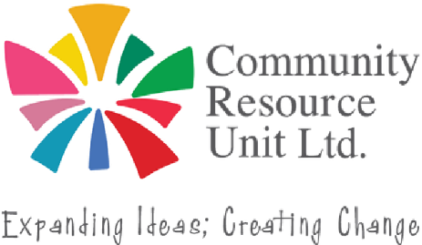

Taking Stock & Aiming High

Preparing for the 2027 school year
The end of the school year can stir a range of emotions for families of students with disability - relief after a challenging year of advocacy, sadness at leaving behind a year of inclusion and progress, or concern about whether the new year will be equally positive.
This free online workshop will help you to revise goals, note helpful adjustments, prioritise what is most important and to prepare for important communication with your child’s teacher/s for the 2027 school year.
This workshop will support families to:
Reflect on the past school year
Identify approaches to build on next year
Prioritise improvements for your child in 2027
Wednesday 11 November 12:30pm - 2:00pm
Online via Zoom
No fee, registrations are essential.
RSVP by 10th November 2026
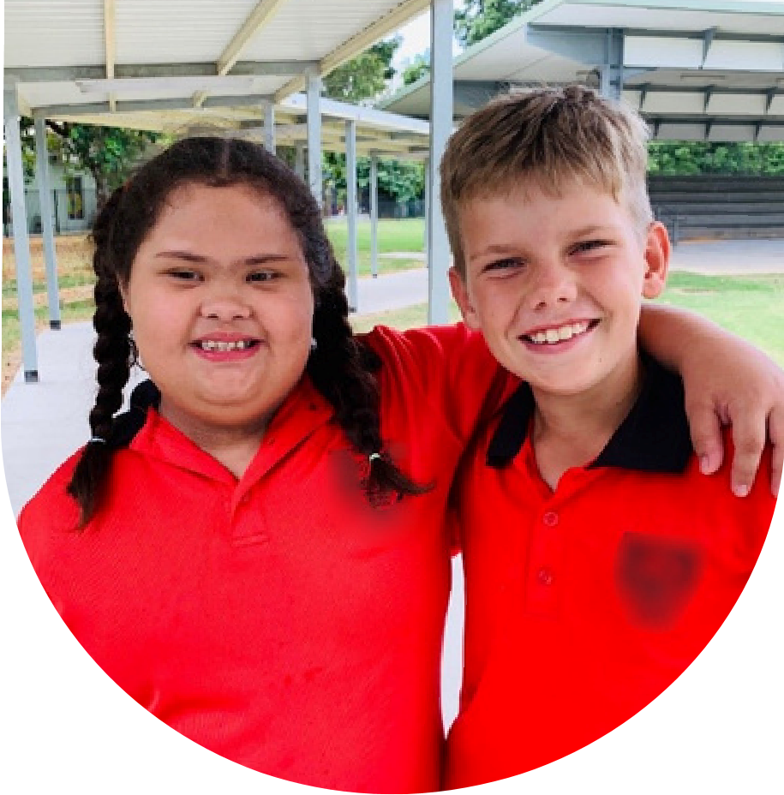
Effectively share key inclusion information with next year’s teachers
Feedback from a 2025 participant of this workshop:
“This workshop was really well timed and I have come away with a great tool to use moving into the new year. Thank you!”
Who should attend:
Parents and carers of school-aged children (Prep to Year 12) with disability. Parents and carers of younger children who are starting to think about/ prepare for the school years are also most welcome to attend.










Register now!
Register now to secure your place or Email: cru@cru.org.au
visit cru.org.au/events/upcoming-events/ Phone: (07) 3844 2211
Please contact CRU if you Website:www.cru.org.au need assistance at attend.

