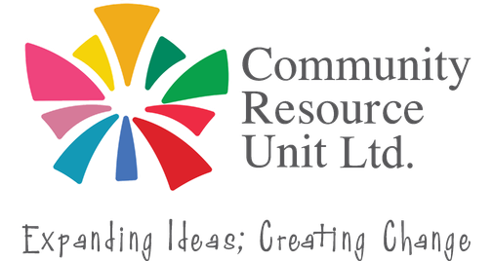
Disability Awareness Training
We all have a role to play in making our society more inclusive.
1 in 5 people in our communities have a disability. We know that community members want to be welcoming and inclusive but don’t always know how.
Every interaction, event, and decision is an opportunity to help people feel welcomed, valued, and included. Join Community Resource Unit (CRU) for an engaging 3.5-hour face-to-face Disability Awareness workshop and discover ways you can confidently create welcoming experiences for people with disability.
Through real-life stories, facilitator experiences, videos, discussion, practical activities, and group exercises, you'll explore issues of accessibility and inclusion and understand why it’s the small things we do that can often make the biggest difference.
Who is it for?
Mon 2nd or Tues 3rd Nov
9:00am - 12:30pm
The Stack
Mt Isa Civic Centre
23 West Street, Mt Isa City
No cost, registrations essential RSVP: Thurs 29th Oct.
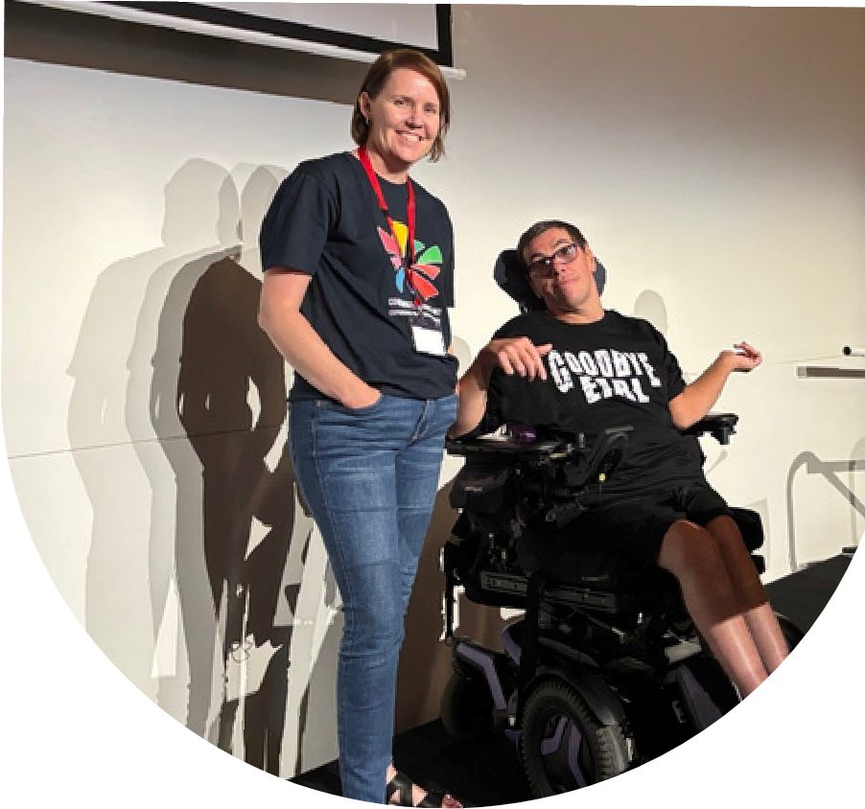
Designed to help businesses, clubs, groups, services, tourism providers... (anyone and everyone who is interested) to feel more confident to be inclusive, and to have more practical strategies to draw on.
"Very thought provoking workshop. I really found this very valuable"
- feedback from previous workshop participant
This workshop was co-designed with people with disability and is presented by CRU facilitators with decades of experience working in the sector.
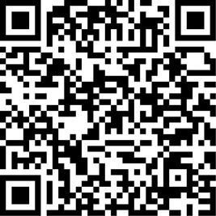
Register your tickets now! https://events.humanitix.com/disability-awareness-training-mt-isa








Register now to secure your place Email: cru@cru.org.au
or visit cru.org.au/events/upcoming-events/ Phone: (07) 3844 2211
Please contact CRU if you need assistance Website: www.cru.org.au
at attend.

