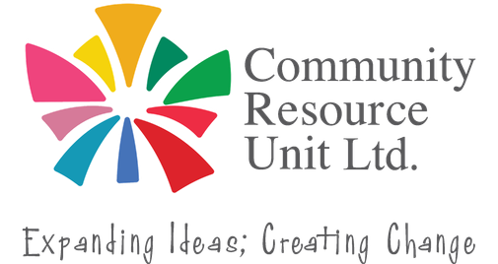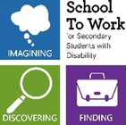
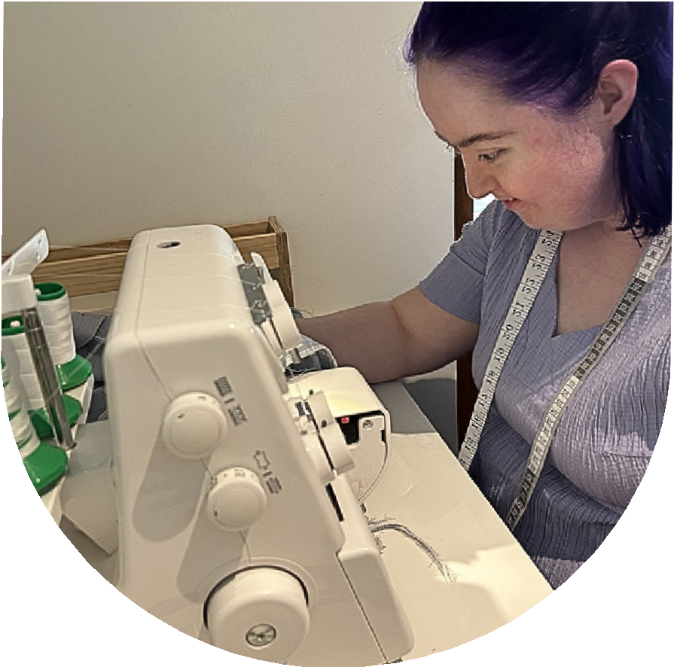
Crafting a Vision for Inclusive Employment

& Bringing others along with you

Meaningful work is possible. This new face-to-face workshop will help you create a clear vision for inclusive employment for your family member. You will also learn how to involve others to help achieve the vision for meaningful work.

Who Should Attend? This workshop is for families of school-aged students with disability. Whether you are just starting to think about work or already exploring work experience or paid employment, this workshop offers practical tools for achieving meaningful employment. Learn to share your vision and involve family, friends and supporters.

At this workshop you will:
Thursday 22 October
9:30am - 2:00pm
Kedron-Wavell,
21 Kittyhawk Dr, Chermside
No fee, registrations essential. RSVP 15 October 2026
- Think big about a positive future for work.
- Create a clear vision for meaningful employment and share it with confidence.
- Start conversations that inspire others to get involved.
- Turn the vision into action by learning how to ask and involve others.

Be part of the day! This event will not be recorded. Join us in person to learn how to craft your vision and connect with people who share similar experiences.

Register your tickets now.


Register now to secure your place or visit cru.org.au/events/upcoming-events/


Please contact CRU if you need assistance to attend.

 Email: cru@cru.org.au
 Phone: (07) 3844 2211

Website: www.cru.org.au

