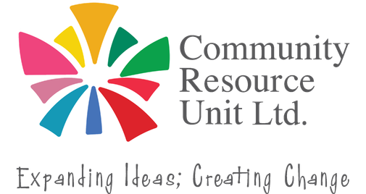

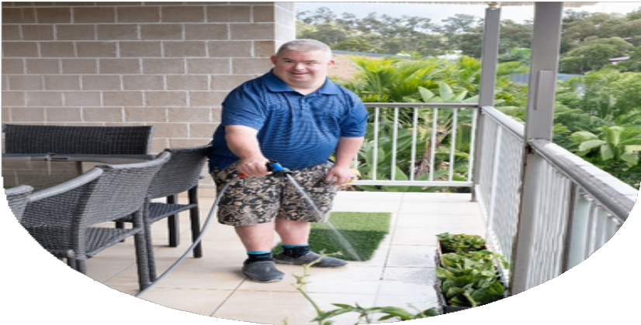

Making the Move
Turning the Dream of Home into Reality

Having a home of your own can offer greater independence, choice, safety and opportunities for personal growth.

For people with disability and their families, moving out of the family home can feel overwhelming. There may be uncertainty about housing options, managing supports, staying within budget and planning for long-term safety and wellbeing.

Whether you are exploring a home of your own or supporting a family member to consider their future, this workshop will provide practical information and guidance to help you move forward with confidence.

Join us to:
- Discover practical first steps you can take - even while still living at home
- Explore ways to choose the right housing option, manage supports within a budget, and maintain safety and wellbeing
- Develop a clear vision and identify practical strategies to help make a home of your own a reality.

Thursday, 12 November
9:30am - 12:30pm

Online (Zoom) 
$5 - $25 for people with disability and family members.
$40 for professionals and allies.

RSVP by Sunday 8 November 2026.

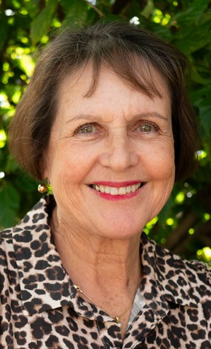
About the Presenter:
Dianne Mandeville is the parent of a 39-year-old son with complex disabilities. Alongside working towards a secure and meaningful future for him, she has supported many families and individuals over the years in envisioning and planning for inclusive lives and individualised living arrangements.

Take the first step towards a home of your own - register today.



Register now to secure your place or visit cru.org.au/events/upcoming-events/


Please contact CRU if you need assistance to attend.

 Email: cru@cru.org.au
 Phone: (07) 3844 2211

Website: www.cru.org.au

This workshop is part of the My Home, My Way initiative by National Alliance of Capacity Building Organisations (NACBO).

