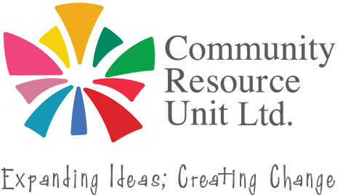

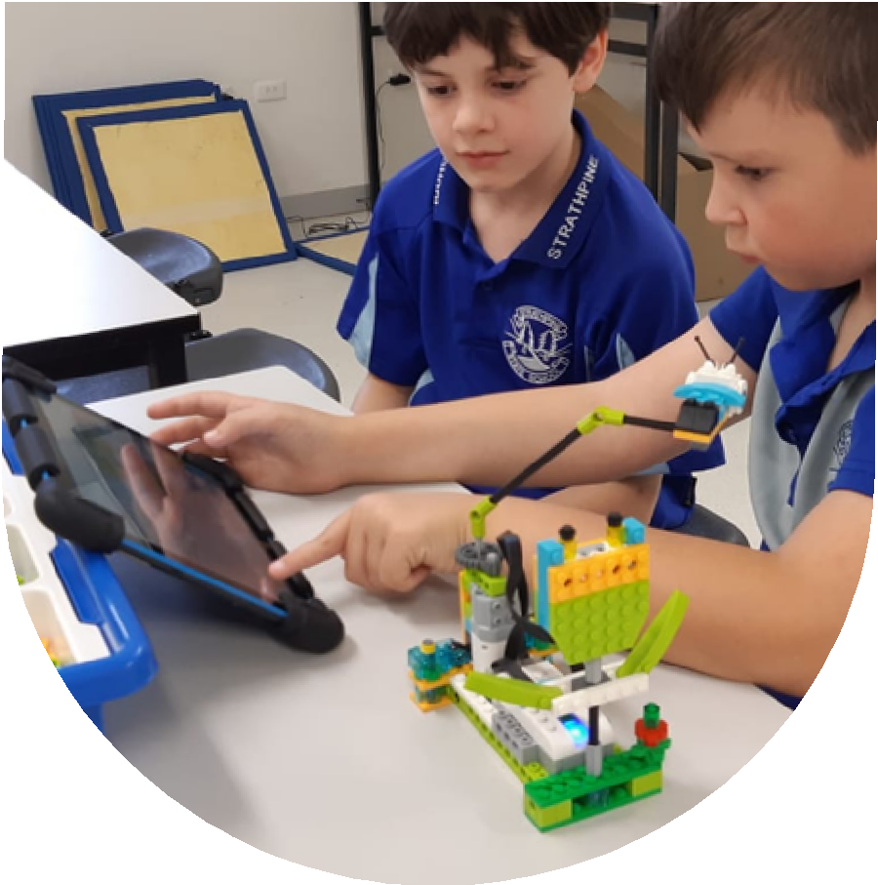
Inclusion and Belonging at the local school
The parent advocacy toolkit

Inclusion at the local school is possible and has been so for decades. It is a human right and supported by research and evidence. Yet making inclusion a reality for every child is not always easy. Parents play a vital role in working with school to achieve meaningful inclusion.

This free, face-to-face, and interactive workshop offers a valuable opportunity to connect with others and learn practical ways to support inclusive education for your child with disability.

This workshop is led by CRU facilitators passionate about inclusive lives for children with disability.


This workshop will help you to:
Thursday 29 October
9:30am - 2:00pm

Sopo, 36 Scarborough Street Southport, QLD 4215
No fee, registrations are essential.
RSVP by 21 October 2026
- Recognise your child’s strengths
- Build a vision for inclusion and understand inclusion at school
- Learn about rights and supports
- Work well with the school team and advocate with confidence

“Every time I attend these workshops I learn new information and tips that help me to stay focused and passionate!”

Register now to learn more about inclusion at school!


Register now to secure your place or visit cru.org.au/events/upcoming-events/


Please contact CRU if you need assistance at attend.

 Email: cru@cru.org.au
 Phone: (07) 3844 2211

Website: www.cru.org.au

This event is supported by funding from the Australian Government Department of Health, Disability and Ageing.

