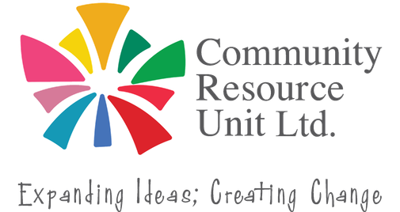

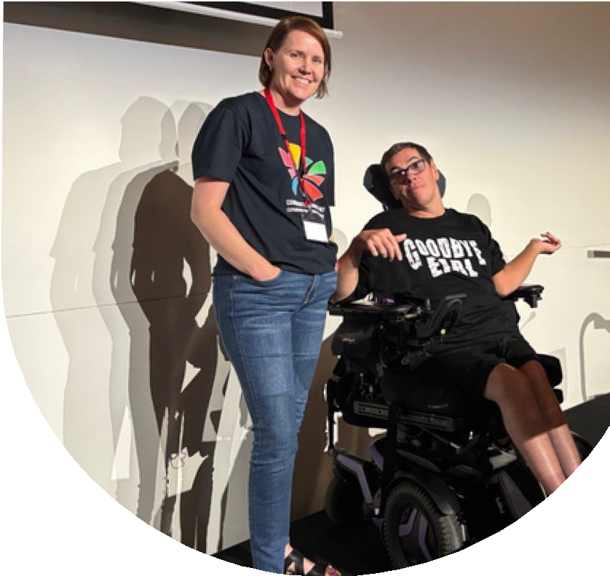
Disability Awareness Training

We all have a role to play in making our society more inclusive.
1 in 5 people in our communities have a disability. We know that community members want to be welcoming and inclusive but don’t always know how.

Every interaction, event, and decision is an oppotunity to help people feel welcomed, valued, and included. Join Community Resource Unit (CRU) for an engaging 3.5-hour face-to-face Disability Awareness workshop and discover ways you can confidently create welcoming experiences for people with disability.
Through real-life stories, facilitator experiences, videos, discussion, practical activities, and group exercises, you'll explore issues of accessibility and inclusion and understand why it’s the small things we do that can often make the biggest difference.

Who is it for?

Thurs 15th Oct 9:00am - 12:30pm
Charters Towers Regional Council Local Disaster Coordination Centre,
12 Mosman Street,
Charters Towers, 4820.
No cost, registrations essential RSVP: Thursday 8th October
Designed to help businesses, clubs, groups, services, tourism providers... (anyone and everyone who is interested,) to feel more confident to be inclusive, and to have more practical stratagies to draw on.

"Very thought provoking workshop. I really found this very valuable"
- feedback from previous workshop participant

This workshop was co-designed with people with disability and is presented by CRU facilitators with decades of experience working in the sector.

Register your tickets now.

Register now to secure your place or visit cru.org.au/events/upcoming-events/
Please contact CRU if you need assistance at attend.
 Email: cru@cru.org.au




 Phone: (07) 3844 2211

Website: www.cru.org.au

