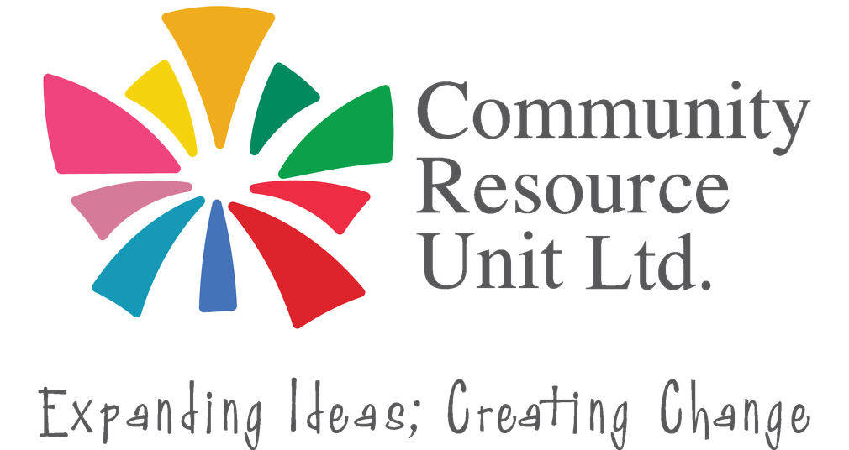

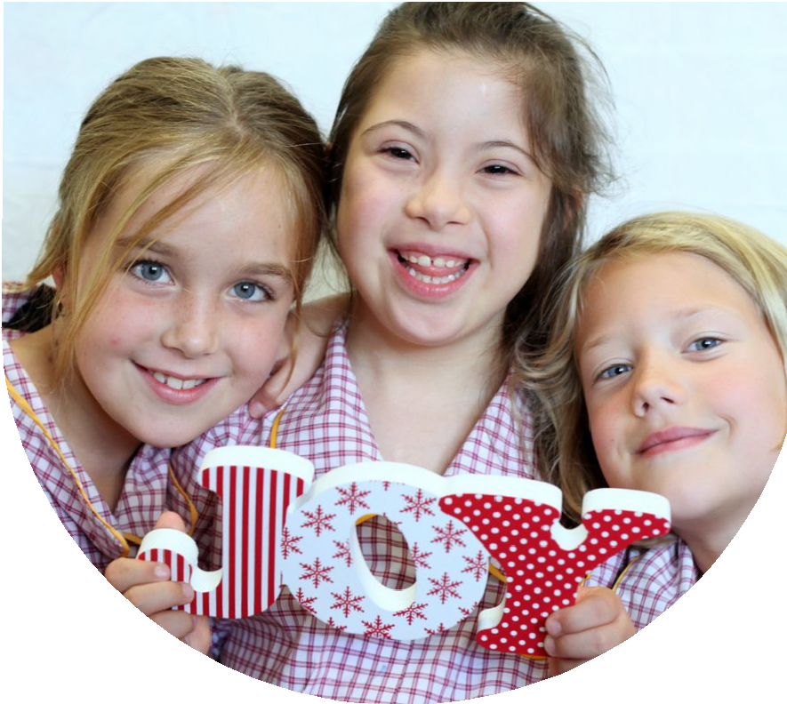
Inclusion as a way of life:
What you can do to ensure your child with disability is in the everyday places

This fully-funded (free to families) face-to-face workshop will be delivered by CRU facilitators passionate about inclusive lives for children with disability.

Every child should feel they belong, and be known and valued, not only by their family, but also by their wider community. It is common though for families with children with disability to worry this may not happen automatically for their child. They may wonder what, if anything, they can do about this.

This workshop will cover:
Wednesday 17th June 2026
9:30am - 2:00pm
Eatons Hill Hotel
646 South Pine Road, Eatons Hill Qld 4037
There is no cost for this workshop. Registration is essential.
- What genuine inclusion looks like and why it matters
- Identifying welcoming people and places in your local community
- Being confident in seizing opportunities for belonging in everyday places
- Strategies that families have found helpful in building an inclusive life for their child

Register now to learn about genuine inclusion.

Register now to secure your place or visit cru.org.au/events/upcoming-events/
Please contact CRU if you need assistance at attend.
 Email: cru@cru.org.au




 Phone: (07) 3844 2211

Website: www.cru.org.au

About the Presenters:

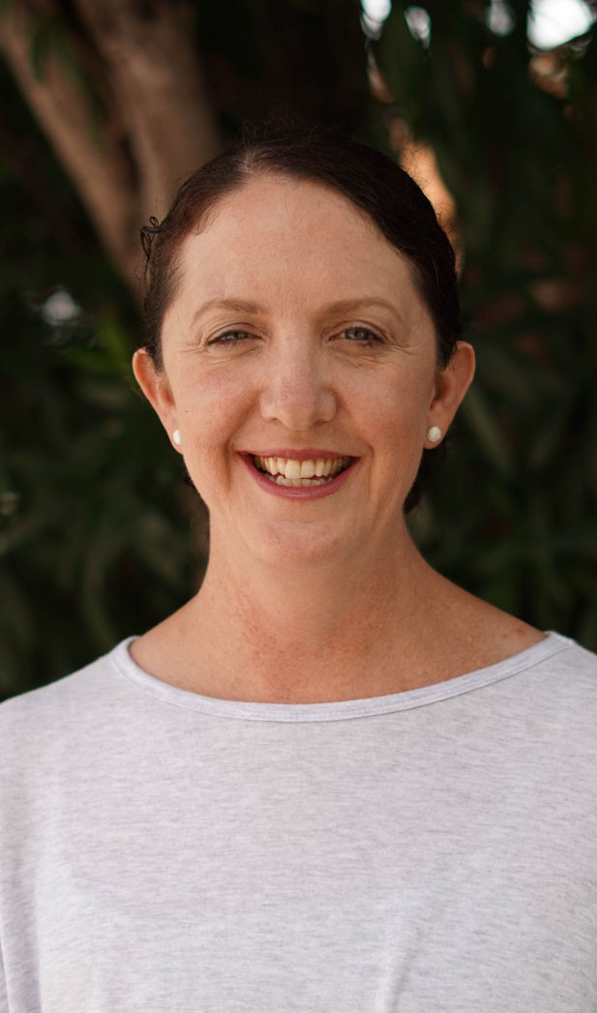

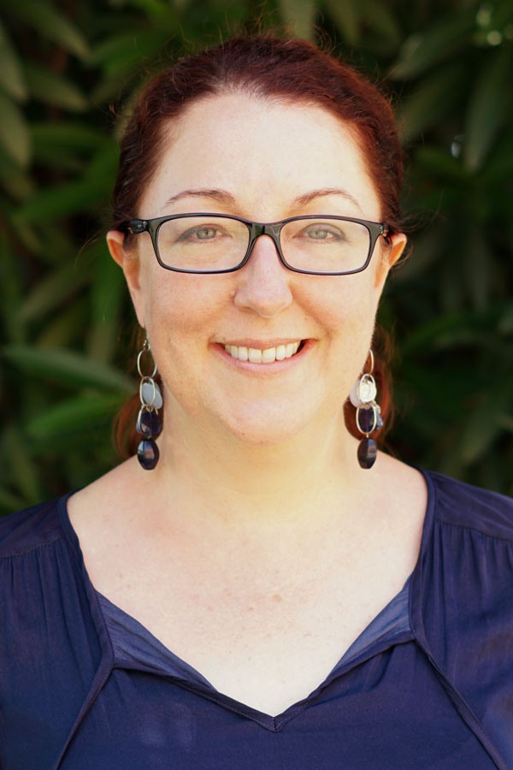

Register now!

Ainsley Robertson

CRU Facilitator
Ainsley Robertson and Lindie Brengman will facilitate this online workshop (use our photos from the CRU website). They are both parents of young adults with disability. They bring to this workshop their combined experience and passion for advocating for their children’s inclusion in the ‘mainstream’ places in their communities.

Over the past 6 years, they have worked as Facilitators on CRU’s ‘Families for Inclusive Education’ project. In this time they have delivered many workshops statewide, and have had hundreds of conversations with parents/carers of children with disability about claiming their child’s right to be at their local regular school, and building their belonging in their local communities.

Lindie and Ainsley believe it is never too early, and never too late, for a family to develop a vision of inclusion for their child, and to take steps towards achievement of this vision.

Lindie Brengman

CRU Senior Facilitator

Register now to secure your place or visit cru.org.au/events/upcoming-events/
Please contact CRU if you need assistance at attend.
Email: cru@cru.org.au
Phone: (07) 3844 2211
Website: www.cru.org.au

