The Right to be Disabled

Online with Norman Kunc and Emma van der Klift


6pm – 7.15pm Tuesday 28 April or

10am – 12pm Friday 1 May

Online via Zoom


Description
Norman Kunc and Emma Van der Klift (Canada) challenge the pervasive idea that a person’s disability needs to be ‘fixed’ or minimised to increase their quality of life.

Their online presentation will help you
- Shift thinking from ‘fixing’ and ‘awareness’ to acceptance and pride
- Focus on the gifts and strengths of each person
- Advocate for inclusion and rights for all ages
- Rethink which supports are most effective and helpful

Norman and Emma are internationally recognised speakers, authors and advocates within the disability rights community. Norman was born with cerebral palsy and attended a segregated school until he was 13. Emma was diagnosed as Autistic as an adult and is an active member of the Neurodiversity community and movement.
Attend either:
- Tuesday evening
hosted by CRU or
- Friday morning with live
Q&A with Emma and Norman


Tickets $5 - $25 people with disability and family members $75 workers, friends and allies
RSVP: Monday 20 April
Registrations Essential
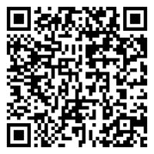

For more details & tickets visit www.cru.org.au/events/ upcoming-events

