
Getting Started on the

Journey to Meaningful Employment: Webinar 1 Webinar Series



10:30am – 12:00pm | Thurs 26 March 2026

Online Workship | via Zoom


Description
This first webinar in the 2-part series will provide secondary students and their families with an opportunity to stop and consider what meaningful work is; why it is important and why it should not be dismissed as unachievable for people with disability. Practical steps and tips will be offered and we will explore various school to work pathways, and include linking an NDIS support plan goal to employment.
This webinar will cover:
- Exploring why having a job is important for everyone
- The benefits of starting now
- How to write a Vision Statement
- Learn how to identify your young person’s interests and strengths
- Roles through connections and community
- Understanding conditions of success

Tickets There is no cost to attend this webinar, but registrations are essential.

RSVP: Thurs 19 March 2026

For more details & tickets visit www.cru.org.au
Please contact CRU if there is anything we can do to assist you to attend this event.
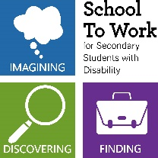

This webinar is fully subsidised as part of the Community Inclusion Capacity Development program through the Department of Social Services.

