

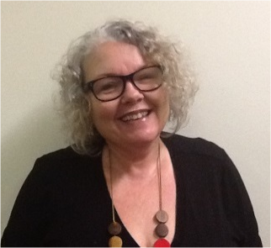
Responding Well to People with “Challenging Behaviour” and its Messages
with Ann Greer
Face
Face to Face event


9.30am – 4pm | Thurs 12 March 2026


Bowen Neighbourhood Centre


34-40 Gregory Street, Bowen

Description
This workshop encourages participants to understand more about the situations in which people with “challenging behaviour” find themselves and explores how to best respond to support your person.

Presenter Ann Greer explores how to develop strategies with the person, so that they can better understand their motivations, effects and consequences of their behaviour.
The workshop will involve information sharing, practical tips & strategies and learning through stories.

Topics covered will include:
- Defining and describing “challenging behaviour”
- Communication and its role in behaviour
- Practical tips for making a start
- Understanding our part in the behaviour of others.

Who Should Attend?
Anyone supporting a person labelled as “challenging” – whether as a parent, family member, friend, or a work role.

Contact us: 07 3844 2211 cru@cru.org.au
This event is supported by funding from the
Australian Government Department of Health, Disability and Ageing.


Tickets
$10-$50 People with Disability & Family Members
$150 Workers, friends and allies
RSVP: Thurs 26 February 2026
Registrations Essential



For more details & tickets visit www.cru.org.au/events/upcoming-events/

Please contact CRU if there is anything we can do to help you to attend this event.




