
Welcoming People Well

Inclusive Councils, Inclusive Communities


Face to Face Workshop – Blackall & Tambo

 Tues 24th February – 9am – 12:30pm Tambo Multipurpose Centre, 26 Arthur Street, Tambo

Wed 25th February – 9am – 12:30pm
The Birdcage Hotel Function Room
31 Duck Street, Longreach

Description
1 in 5 people in our communities have a disability and we know community members want to be welcoming and inclusive but don’t always know how.
This workshop is designed as an introduction to the fundamentals of how to include people with disability.
By focusing on people’s strengths and our commonalities, Welcoming People Well takes participants beyond simply improving physical access and will assist you to be truly inclusive of all people.

Who is the workshop for?
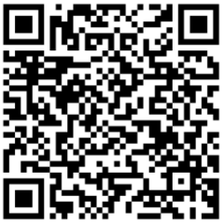
Designed to help businesses, clubs, groups, services, tourism providers… (anyone and everyone who is interested), to feel more confident to be inclusive, and to have more practical strategies to draw on.
This Inclusive Councils, Inclusive Communities project received funding from the
Australian Government Department of Health, Disability and Ageing.

Learning Objectives
- Know what exclusion and inclusion means for people with disability
- Learn about the social model of disability and common myths about disability
- Be introduced to principles of inclusion
- Think about practical things people can do to welcome and include people with disability
Up to 25 people per workshop

About Community Resource Unit (CRU)
CRU believes people with disability deserve access to the same life as everybody else. For over 35 years, CRU has been working across Queensland to help people with disability take control of their lives and take their place in their community.

