|  |  |
| --- | --- |
| **About this workshop**  Social Role Valorisation (SRV) helps to explain why people with disability are highly vulnerable to being excluded from everyday life.  While this rich framework explores how people are marginalised, importantly it also offers strategies to address these processes and increase the chances of people with disabilities to belong to, and contribute in our community.  In this interactive workshop the core themes and principles of SRV will be explored through presentations and discussion.  *"I enjoyed the collaborative teaching. It highlighted the many options, many interpretations (not right/not wrong) and was a mini-demo of brainstorming and different perspectives!"*  – previous workshop attendee  **Who should attend?**  This workshop is being offered as a leadership development opportunity for **people with disability and family members only**. It is designed for people who are prepared to be challenged in their thinking and are serious about working towards better lives for people with disability.  For workers who are interested in this workshop, please see the Values in Action Association website for upcoming dates at <http://www.viaa.org.au/>  If you are travelling from regional Queensland to attend and would like recommendations about accommodation, please get in touch.  Contact us: 07 3844 2211 [cru@cru.org.au](mailto:cru@cru.org.au) Sign Language Interpretation symbol. Indicates that sign language interpretation is available on request for this workshop.Interpreter symbol. Indicates that people with limited or no English proficiency can ask for an interpreter when attending this workshop. | **Tickets symbolTickets**  *$150 people with disability and family members  *[If cost is a barrier to attending,](mailto:cru@cru.org.au)  [please contact CRU to discuss](mailto:cru@cru.org.au)  **Day 1:**  **Thurs 6 Nov 8.45am– 5pm**  **Day 2:**  **Fri 7 Nov 9am – 5pm**  **RSVP: Wed 22 October, 2025**  Registrations Essential    For more details & tickets visit [www.cru.org.au](https://communityresourceunit.sharepoint.com/Programs/Program/Fee%20For%20Service/Admin/Archive/CRU%20Event%20Flyer%20Template/www.cru.org.au)/events/  Please contact CRU if there is anything we can do to assist you to attend this event. |

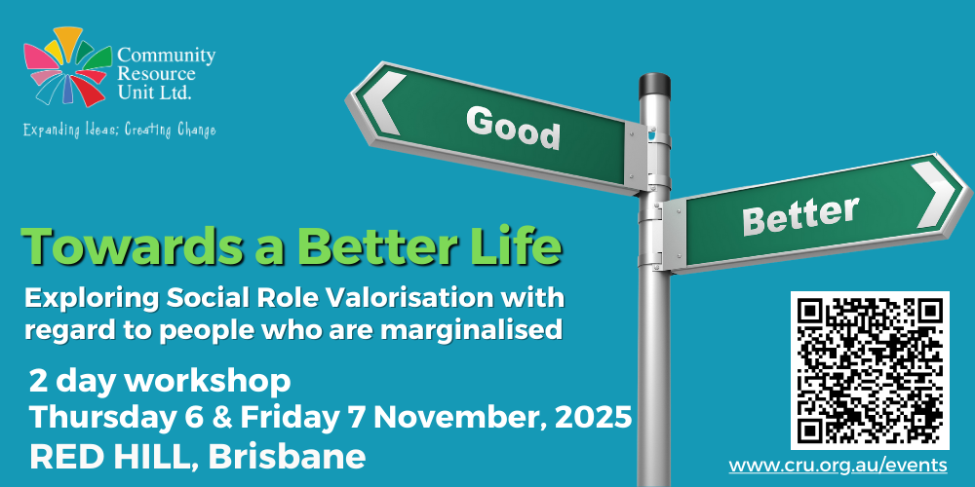

**About the Presenters**

|  |  |  |
| --- | --- | --- |
| **A person in a white shirt** | The workshop will be led by **Danielle Mason**, an accredited SRV Teacher of Towards a Better Life. Danielle was first exposed to SRV when working as a support worker for a small disability service where she worked alongside people with disability living in a long-stay health facility. SRV has remained relevant and useful across a range of service settings and roles, as well as in her personal life.  In her current work role at Community Resource Unit, Danielle shares SRV ideas through workshops and mentoring, and uses SRV to guide the development of resources.  ​Danielle is also the President of Values in Action Association, the local SRV group in Queensland. | |
| **Lindie Brengman** is also a Co-Teacher and CRU Consultant, will also be presenting alongside Danielle. Lindie has worked as an Occupational Therapist with children and adults and is currently a Senior Facilitator at CRU, working on the 'Families for Inclusive Education' project since it began in 2019.  Through her own experience advocating for her daughter with disability, Lindie developed a passion for sharing the importance of an inclusive education and is a founding member of the Queensland Collective for Inclusive Education.  Lindie finds SRV ideas extremely important in planning with her daughter for a good life and is passionate about teaching SRV so other vulnerable people and those that care about them can benefit. | | A person wearing glasses and a blue shirt |

Contact us: 07 3844 2211 [cru@cru.org.au](mailto:cru@cru.org.au)

Contact us: 07 3844 2211 [cru@cru.org.au](mailto:cru@cru.org.au) 