Developing a Visual Resume for Work

10.00am – 11.30am | Wednesday 17th September 2025

Online Workship | via Zoom

Description
This webinar will focus on visual resumes, an alternative to a traditional resume, and show what it is and how others have used it to help find meaningful paid employment in their community.
The webinar covers the key concepts of Visual Resumes:
- What a visual resume is, and when it is used
- The key components of a visual resume
- Considerations when developing a visual resume
- Examples of visual resumes
- Creating speaking notes to accompany the visual resume
- How to get started crafting a visual resume of your own.
The content of this webinar has been derived from the work of Marc Gold & Associates. The webinar will include family stories of what is possible and live Q&A.
Tickets There is no cost to attend this webinar, but registrations are essential.
RSVP: Monday 15th September 2025
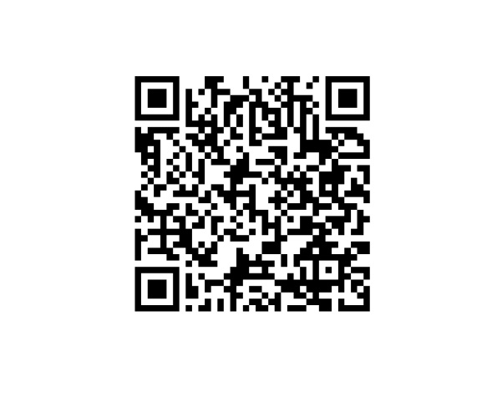

For more details & tickets visit www.cru.org.au
Please contact CRU if there is anything we can do to assist you to attend this event.
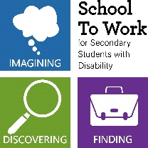
The project is being provided as part of the Information Linkages and Capacity building (ILC) program through The Department of Social Services.

