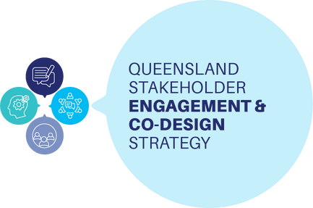

**Co-design training workshops**

# Co-Design in Action: Tools, Connection and Processes delivered by QDN

This online training will help you learn:

How to create successful co-design approaches

How to select appropriate tools, questions and resources to get the best results

What conditions support good co-design

Online via Zoom

# Co-Design Essentials delivered by CRU

This face to face training will help you to:

Be clear about what co-design is and isn’t Know why co-design is needed

Understand the roles and responsibilities of people to involve in co-design processes

Feel confident, empowered and equipped to contribute as a co-designer

# For more information scan here:

**In-Person Locations:**

Caboolture Brisbane Gladstone More coming...

Or visit [www.qdn.org.au](http://www.qdn.org.au/)

Funded by

