A Real Job or Just filling in Time?:

How Social Role Valorisation can help Webinar

10:00am – 11:30am | Wednesday 30th July 2025

Online Workship | via Zoom

Description
Every young person deserves to get a job they love. Societal attitudes and low expectations around disability present an unfair barrier to young people.
This webinar will be presented by Lindie Brengman, accredited co-teacher with the Australian Social Role Valorisation Association (ASRVA). The webinar will include pre-recorded videos by Jane Sherwin one of only two senior trainers in Social Role Valorisation (SRV) in Australia.
If you are a parent or supporter of a young person with disability who wants to see them find real work that they enjoy, then this session is for you.
The webinar will include live Q&A.

Tickets There is no cost to attend this webinar, but registrations are essential.
RSVP: Wednesday 23rd July

For more details & tickets visit www.cru.org.au
Please contact CRU if there is anything we can do to assist you to attend this event.
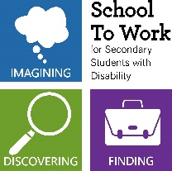
The project is being provided as part of the Information Linkages and Capacity building (ILC) program through The Department of Social Services.

