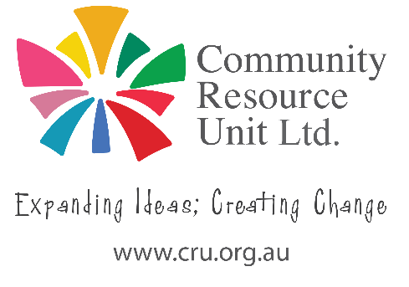
Developing a Pitch
Have a start on answering the questions below regarding the young person.
Ideas to include | Response
Introduce the young person (refer back to positive introduction)
Describe some of their skills or positive personality traits related to the job they are seeking

Examples of types of tasks they can offer an employer (and how the company might benefit)
Give an example of a success
- Something that went well
- An example of completing a task they enjoyed
The next step – Are you seeking further experience, advice, or a formal interview?
Thank the person for their time

