 |  | Saturday Morning Plenary:
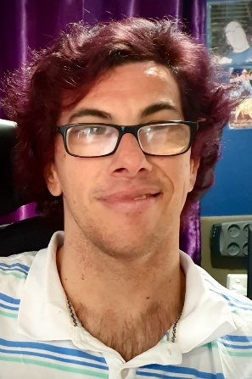 |  | Dan Read  Presenting: Take the Notes but Make Your Own Music  Dan Read is a songwriter/musician and business owner who writes, collaborates and performs with other talented musicians. He has completed a Diploma in Music and a Certificate III in Business Studies. As a seasoned traveller and natural storyteller, he enjoys meeting interesting characters from whom he draws inspiration for new stories and songs. Dan’s own story is always the same – find your passion, follow your dreams, work hard to realise those dreams and take control of the direction of your life.  Dan continues to look with hope (and a wicked sense of humour) for possibilities in the future and that searching is backed up by a remarkable determination, energy for life and a refusal to see obstacles as a barrier to his following his passion.

 |  | Saturday Afternoon Plenary:
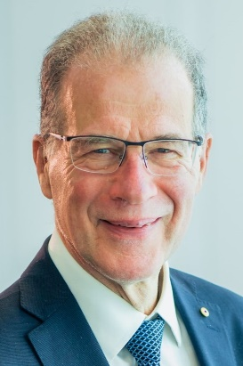 |  | Professor Bruce Bonyhady  Presenting: Reflecting on Change – twenty years investment in the NDIS  Professor Bruce Bonyhady is the Director at the Melbourne Disability Institute at The University of Melbourne. He is a disability reformer, economist and one of the key architects of the National Disability Insurance Scheme (NDIS). He was Co-Chair of the NDIS Review in 2022-23 and was the inaugural Chair of the National Disability Insurance Agency (NDIA) from 2013-16.  Professor Bonyhady is the father of three adult sons, two of whom have disabilities and in the 2010 Queen's Birthday Honours, he was appointed as a Member of the Order of Australia for services to people with disabilities, their families and carers, and to the community as a contributor to a range of charitable organisations.

