 |  | Inclusive Education
 |  | 
  SATURDAY WORKSHOP  15th March 2025  Note: Repeat session  from Friday, with different  co-presenters each day! |  | Why the struggle, and why we must persist!  Inclusive education is a human right, supported by Australian legislation and policy. Over 50 years of research clearly states that inclusive education benefits all. So why does inclusive education remain so elusive for students with disability in Australia?  This session will explore the history of education in this country, and how it has led to the current barriers. We will examine what can be learnt from countries where the inclusive education movement has made solid gains and explore approaches that may lead to similar success here. We will identify practical steps to further progress inclusive education in Australia.  Learning Objectives  When undertaken as training for family members, carers or supporters, participants will:  - Learn about evidence-based strategies and long-term outcomes for inclusive education.  - Build skills and capacity including through peer learning, to support children with disability to be included and build social connections in mainstream and community environments.

 |  | Meet Your Presenters
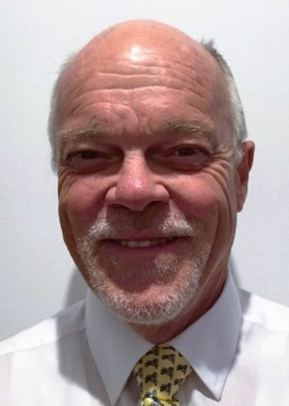 |  | Dr Bob Jackson started in disability as a direct care staff member in a huge institution in NSW. In the 1970s he worked as a psychologist, institution superintendent, service manager and Regional Director with the State Disability Services Commission of WA.  From 1995, Dr Jackson has been closely involved with school inclusion, advising families, teachers, schools and education systems on the rationale and practicalities of inclusion. Dr Jackson was contracted by the Federal Government to review disability discrimination in education in Australia and other countries and has appeared as an expert witness in several discrimination cases since the early 1990s. Currently Dr Jackson is working as a private consultant in disability and education but remains an Adjunct Associate Professor at Curtin University. He was a co-founder of All Means All, and a foundation member of the Australian Coalition for Inclusive Education (ACIE) and the teacher professional organisation Inclusive Educators Australia.
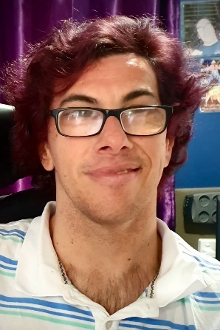 |  | Dan Read will join the inclusive education workshop on Saturday. Dan will share his broader life experiences in the plenary session and then will join the inclusive education workshop to share his school experiences, the impact they have had on his life and the learnings he has taken from them and now shares with others.  Dan Read is a songwriter/musician and business owner who writes, collaborates and performs with other talented musicians. He has completed a Diploma in Music and a Certificate III in Business Studies. As a seasoned traveller and natural storyteller, he enjoys meeting interesting characters from whom he draws inspiration for new stories and songs. Dan’s own story is always the same – find your passion, follow your dreams, work hard to realise those dreams and take control of the direction of your life.

 |  | Employment
 |  | 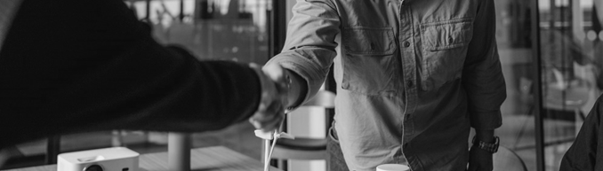
SATURDAY WORKSHOP  15th March 2025 |  | Customised Employment  Since 2020, CRU, Family Advocacy (NSW) and Imagine More (ACT) have worked together on a project called ‘From School to Work’ funded by the Department of Social Services, to support high school students with disability and their families to engage with employment. ‘From School to Work’ provides information to help students and their families build confidence and explore what work could look like for them.  Through that project we have explored in depth the idea of Customised Employment. In this workshop, Fiona McIntosh and Katie Hodges, two of our interstate partners in the School to Work project will give an introductory overview of the stages of this process and share stories of Customised Employment in action.  Learning Objectives  When undertaken as training for people with disability, family members, carers or supporters this workshop will:  - Build capacity to design, find and maintain employment in the open labour market, including self-employment.  - Build capacity, understanding and skill to support a person with disability to transition from school to employment or for adults to transition to new employment opportunities.

 |  | Meet Your Presenters
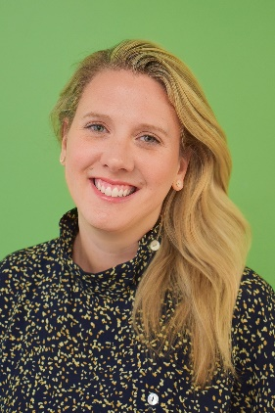 |  | Katie Hodges brings over 15 years’ experience working in the disability sector. Originally from the U.S., Katie joined the School to Work Project at Resourcing Inclusive Communities (NSW) in 2020.  Katie is passionate about empowering families with valuable, evidence-based information and resources, so that they can best support their family member living with a disability to be included in the community. Through the School to Work Project, Katie has accessed Customised Employment Training from Marc Gold & Associates in the United States and works closely with the consortium partners to inform families and professionals about the benefits of the Customised Employment approach.
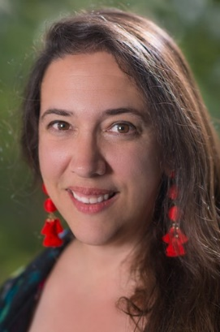 |  | Fiona McIntosh has extensive experience in Customised Employment, supporting people with intellectual and developmental disability to achieve meaningful and sustainable work.  At Imagine More (ACT), she facilitates workshops, webinars, and peer groups that empower families and educators to create employment opportunities with and for people with disability. Fiona combines professional expertise with personal insight as a family member. To people with disability and a woman with disability. She has over 30 years in policy, program development, and stakeholder engagement—including 15 years focused on disability in government and non-government sectors.  Passionate about inclusion and belonging, Fiona is dedicated to helping families and communities imagine and achieve meaningful, valued roles for people with disability.

 |  | Supported Decision Making
 |  | 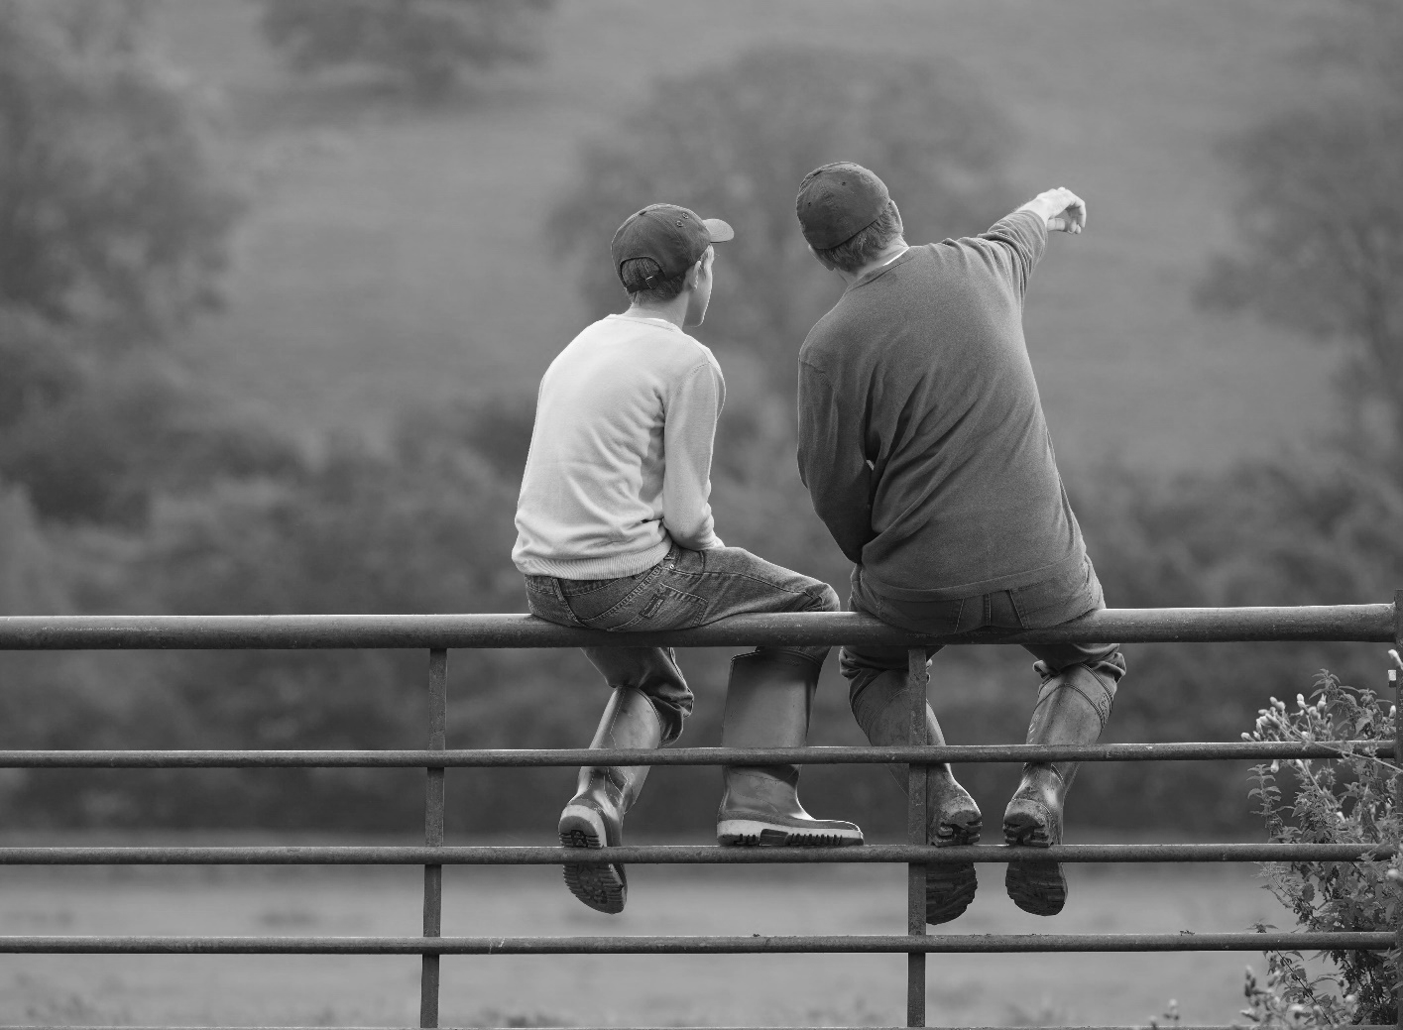
SATURDAY WORKSHOP  15th March 2025  Note: Repeat session  from Friday, with different  co-presenters each day! |  | Voice, Rights and Risk: Exploring Supported-Decision Making  This workshop grounds supported decision-making in human rights and explores two complex areas of supported decision-making in practice: supporting communication and enabling risk.  How do we ensure that each person is supported in the way they need to make decisions and to have their will and preferences understood, respected and translated into action?  The workshop also explores enabling risk. Taking risks is a normal and exciting part of life and an important part of learning about ourselves and the world. As risk comes with the possibility of negative consequences, how best to support a person to make risky decisions?  Learning Objectives  When undertaken as training for people with disability, family members, carers or supporters this workshop will:  - Build capacity to support increased independence and life skills including lifelong learning through understanding and maximising supported, rather than substitute, decision making.  - Build capacity and skills to develop, or support others to develop life skills including decision-making, problem-solving and lifelong learning.

 |  |  | Meet Your Presenters
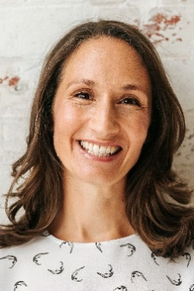 |  |  | Doctor Michelle Browning is passionate about supporting individuals and organisations to develop their skill in the practice of supported decision-making. She is a Churchill Fellow and has completed doctoral research into the practice in Canada.  Michelle has been involved in developing, implementing and evaluating supported decision-making projects across Australia. She facilitates training, practice groups and supervision for supporters wanting to build their confidence as practitioners. She also provides training for decision makers wanting to understand more about decision making and their rights.
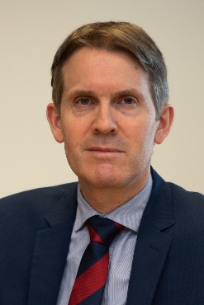 |  |  | John Chesterman is the Queensland Public Advocate. A lawyer and historian by training, John has expertise in the fields of human rights, guardianship, supported decision-making, powers of attorney and elder abuse. Prior to taking up his current position John was Victoria’s Deputy Public Advocate. He has previously undertaken a Churchill Fellowship on the topic of adult safeguarding, and his books include, as co-author, The politics of human rights in Australia (CUP).
Dale & Anita Speed will share their experiences so far around supported decision-making and enabling risk: Dale as a decision-maker and Anita as a family member.
Dale is an open-hearted and adventurous young man from Brisbane who lives in his own home, has a job, good friends and an active social life. Dale is a cricketer, a passionate supporter of his favourite sporting teams, and an international traveller. Dale works as a Maintenance Assistant, and his big dream is to get a loader license and drive earthmoving equipment for a job one day. Anita, Dale’s mother, is interested in how social and business values can intersect, and has worked across the disability and corporates sectors. She is the secretary of Values in Action Association, a Queensland organisation promoting Social Role Valorisation (SRV). Along with family and trusted friends, Anita and Dale are still learning how best to understand and manage risk in decisions that are important to Dale.
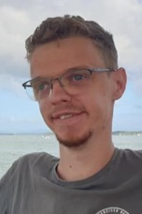
 | 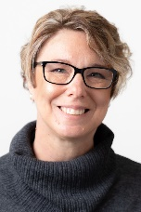

Behaviour and Sensory
and Movement Differences
 |  | 
SATURDAY WORKSHOP  15th March 2025  Note: This workshop is complementary to Friday’s workshop on this topic |  | Looking Behind the Behaviour:  Part B - Sensory, Trauma and Nervous System Insights  To be able to thrive in life, we first need to have our fundamental needs met. Understanding sensory and movement differences, what is going on with a person’s nervous system, trauma and other factors can each and all play a role.  Learning Objectives  When undertaken as training for people with disability, family members, carers or supporters this workshop will:  - Build capacity and understanding of impacts of disability or differences on a person and their behaviour which, when not well understood and supported, are an impediment to social and community participation and living as independently as possible.  - Build capacity and skills to develop, or support others to develop life skills to support increased independence.

 |  | Meet Your Presenters
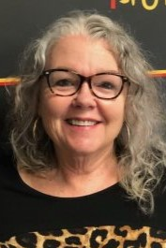 |  | Ann Greer has over 30 years’ professional experience working with people whose behaviours are seen as challenging. As well as drawing on the teachings of Donnellan, LaVigna and Willis, most of her learning and understandings have come from her greatest teachers, people with disabilities themselves.  Ann works with people with disability and their families across Australia to develop creative options and understand what’s possible in making a good life. Ann is the mother of three adults, two of whom live with disability.
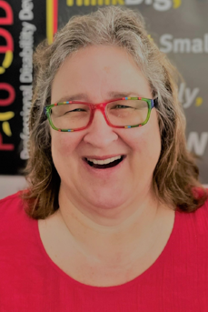 |  | Joyce-Lyn Smith has 28 years’ professional experience supporting people with complex support needs in a variety of environments and settings. Living in Townsville, she is the Clinical Director at PoDDSS (Professional Disability Development Supports & Services) and has previously worked in the Intensive Behaviour Support Team with the Queensland government.  Following completion of the mentoring program with Professor Anne M. Donnellan, University of San Diego and Martha R. Leary (SLP), Nova Scotia in 2009, Joyce-Lyn collaborated with Learning Disability & Mental Health Nurse Karl Jacks to develop their workshop on sensory and movement differences.
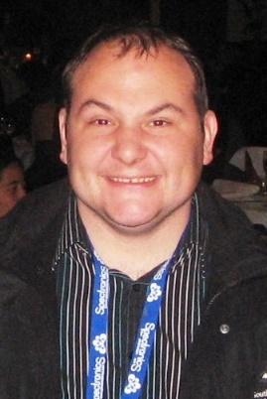 |  | Rodney Mills: For many years Rodney was put in the ‘too hard basket’ because he was exhibiting ‘challenging behaviours’ on an almost daily basis.  Today Rodney is a professional consultant, teacher and trainer, who worked for 10 years in a paid job at the organisation that used to support him.  Rodney runs his own business and presents at conferences and workshops. In his work he shares insights about living with Autism and OCD and how he has gradually built a meaningful life where he is no longer defined by these labels and by ‘behaviour’.

 |  | Friendships & Connections
 |  | 
 |  | Friendship, connection and the importance of freely given relationships
SATURDAY WORKSHOP  15th March 2025 |  | We can’t buy friends; we can’t make people be friends, but we can do some things that increase the chances for friendship and connection to happen. The stark reality is that for some, the only people who really know and appreciate them are family members and paid workers. Relationship and connection is seen as an optional add-on after all other ‘care’ is provided rather than a fundamental human need.  In this workshop we will hear stories of people both preventing and remedying isolation. They contain intentional strategies that have helped people move from isolation to more connected lives. This is an opportunity for families and paid supporters to learn strategies that will increase the chances of connection.  Learning Objectives  When undertaken as training for people with disability, family members, carers or supporters this workshop will:  - Build capacity and life skills, or support others to build capacity and life skills to develop, sustain and improve relationships.  - Develop capacity including through peer learning, drawing from the experiences of people with disability and families around building connections and relationships towards greater, lifelong independence in the community.

 |  | Meet Your Presenters
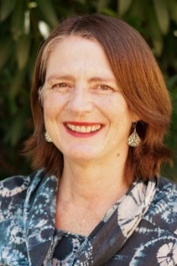 |  | Lisa Bridle is a Brisbane parent of 3 adult children and has a professional background in community development and disability advocacy. Lisa worked at CRU for many years and is passionate about building inclusive communities where everyone's gifts and contributions are valued. In this presentation, Lisa will describe how her son Sean, who is now 30, began friendships at kindergarten and in Year 1 that are still going strong today. She will discuss the approach and strategies used to nurture opportunities for friendships from Sean’s early years to school and beyond, and how these efforts have led to a rich and inclusive adult life.
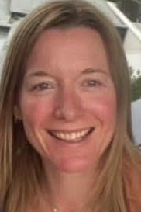 |  | Katrina Fredberg: For over 20 years Community Living Project in Adelaide has created and sponsored dedicated projects to focus on intentionally building networks of support around people with disabilities and their families. Katrina Fredberg who coordinates the Circles Initiative will describe what they do and what they have learnt in that project as well as in the Neighbourhood Circles Project which focused on the important work of building bridges to neighbourhood. There will be people with disability and their families connected with this project at this session.
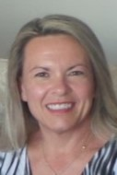 |  | Jenny Smith was the founding member of Capricorn Citizen Advocacy in Rockhampton and is herself a Citizen Advocate. Jenny first began supported decision-making as a key part of her extensive background in disability advocacy. For several decades, Jenny has worked with marginalised and vulnerable people in aged care, disability services, mental health and youth work. Until 2023, she worked for Queensland Advocacy for Inclusion as a Decision Support Advocate. Alongside her continuing advocacy, Jenny currently works as a decision coach.
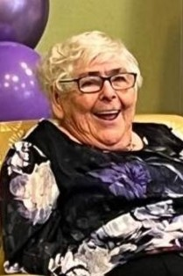  June Arthy 1939- 2024 |  | June Arthy’s friends – Bronwyn Moloney, Marie Vitelli and Robyn Adams  Sharing June’s story – June Arthy was a long-term & respected guest presenter of CRU. June passed away last November at the age of 87, surrounded by family and friends. Two of June’s friends, Robyn Adams and Bronwyn Moloney and her cousin Marie Vitelli will share what was put in place over the past 20 years to help June move from being very isolated, vulnerable and lost in the system to a different life surrounded by a strong network of friends, advocates and family.

 |  | Home
 |  | 
SATURDAY WORKSHOP  15th March 2025 |  | Home of Your Own  This workshop will explore what it takes for people with disabilities to live well in a home of their own. Drawing on a range of stories, our speakers will highlight the importance of being established in your own home as a launchpad to many other opportunities and a critical piece in planning for succession. The speakers and stories will challenge our assumptions that people are safer in groups; that community is dangerous; and that people will be lonely. We will delve into how people are thinking creatively to achieve this, and you can expect to leave with some practical strategies. This session will have a focus on assisting people to share their homes with housemates.  Learning Objectives  When undertaken as training for people with disability, family members, carers or supporters this workshop will:  - Build capacity and skill to design, find and maintain appropriate individualised home and living arrangement & supports.  - Develop capacity including through peer learning, drawing from the experiences of people with disability and families around transitioning to sustainable, innovative, individualised living arrangements and greater independence in the community.

 |  | Meet Your Presenters
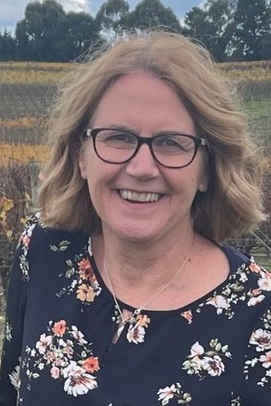 |  | Deb Rouget: For nearly 30 years, Deb Rouget has been involved in the lives of people with disabilities and their families. Deb was one of the founders of Belonging Matters, a capacity building organisation in Melbourne and has enjoyed her role as CEO for 20 years.  Deb has gained much practical experience and wisdom in regard to supporting people with developmental disability to live in their own home, rather than in congregate care. She has witnessed how people flourish when they are supported to authentically live in their own home, develop to their full potential and connect to their neighbourhood. Deb writes and teaches about belonging and social inclusion.
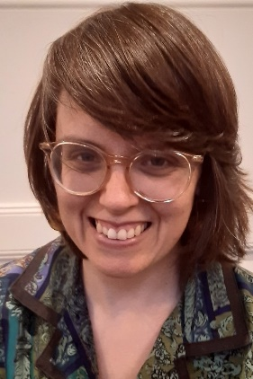 |  | Bec Feldman works for Belonging Matters in Victoria. She assists people with developmental disabilities and their families to think about and explore home, in community. She provides mentoring and advice for people who would like to move into their own home with a range of supports, rather than live in traditional segregated housing.  Bec also works on a project for a large service provider in Melbourne aimed at creating more individualised and inclusive lives. She was a founding board member of the not-for-profit charity Neighbourhood Connect and has a passion for local community and the connections, care and sense of belonging that can make magic happen in and around people’s homes, neighbourhoods and local communities. In her spare time, Bec enjoys yoga, theatre and mostly healthy cooking!

