 |  | Friday Morning Plenary:
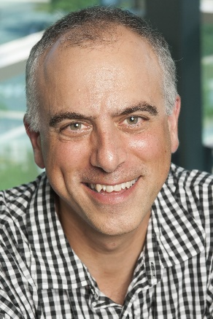 |  | Dan Habib created the Emmy® Award winning New York Times Op-Doc, My DisabilityRoadmap and the new feature film, The Ride Ahead with his son Samuel.  Dan is also the creator of award-winning documentary film, Including Samuel and many other short films on disability related topics. Dan is the Inclusive Communities Project Director at the Westchester Institute for HumanDevelopment. He regularly screens and discusses his films both in the U.S. and internationally, at Universities and conferences, film festivals, and independent theatres. His films have been broadcast nationally on public television stations and translated into 17 languages for use as teaching tools worldwide. From 2014-2017 Dan served on the President's Committee for People with Intellectual Disabilities under Barack Obama.
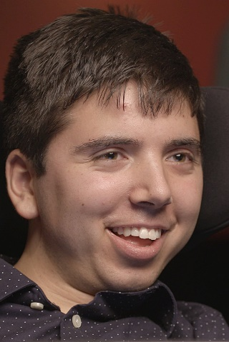 |  | Samuel Habib is a college student and the Emmy® Award-winning co-director of My Disability Roadmap and, The Ride Ahead.  Samuel was a story consultant on the nationally broadcast film Mr. Connolly Has ALS and has been profiled in Forbes Magazine. He also worked as a newspaper columnist, an interviewer of Presidential candidates, and has presented nationally on disability rights, inclusive education, and his transition to adulthood. Samuel uses a communication device (as well as his voice and gestures) to express himself. In addition to exploring his current and future academic and career options, Samuel also navigates significant, chronic health challenges. He works part-time as a multimedia production assistant and presenter at the Westchester Institute for Human Development.

Dan & Samuel Habib Presenting: Our Family Journey
(joining us online from New Hampshire USA)
“You can't teach this. You have to live it. You have to experience it, and you have to be there all the time, every day, around you, in community and schools alongside people of this type of diversity. This is life. This is part of our world. It has to be seen as a normal part of our world.” Dan Habib

Dan and Samuel Habib will join us live online as we open our 2-Day event. Dan and Samuel will share how inclusion at the local regular school and in community prepared Samuel for transition to higher education, employment and an included adult life. Dan and Samuel will make a powerful case for ending the systemic segregation of people with disabilities and share the powerful positive impact that inclusion has on people with disability, their family and their communities. This session will include the opportunity for a live Q&A.

 |  | Friday Afternoon Plenary:
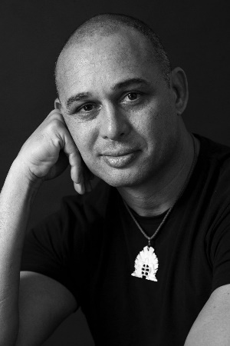 |  | Thomas Mayo  Presenting - Collective Acts of Commitment:  Maintaining Hope in Challenging Times  Thomas Mayo is an Aboriginal and Torres Strait Islander man who lives on Larrakia land in Darwin. He is the Assistant National Secretary of the Maritime Union of Australia, an award-winning author, essayist, orator and a signatory to the Uluru Statement from the Heart. His advocacy and leadership in the push for the rights and recognition of Indigenous peoples spans over twenty years.  His 2024 book Always Was Always Will Be is about how the campaign for peace and justice for Indigenous people continues after the referendum was lost in 2023.

The progress Australia has made since federation in 1901 - from the White Australia policy to multiculturalism; from the blatant exclusion of minorities to efforts at diversity and inclusion; from few workers rights to minimum employment standards - can easily be taken for granted. But none of these gains have come without struggle and backward steps. Nothing can be achieved without hope. Thomas Mayo, Voice to Parliament ‘Yes 23’ campaign leader and bestselling author of Always Was, Always Will Be, reminds us of why we should have hope. He will share his thoughts about what hope is and why it’s important in individual and collective efforts for change. These will be important insights as the ‘Bad Actors’ try to turn hope into hopelessness so they can undo all the good work that has been done.

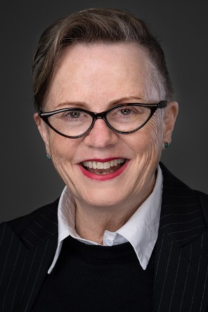 |  | Assoc. Professor Lorna Hallahan  Presenting: For sale in a market: what protects my dignity?  Associate Professor Lorna Hallahan has been a leader in social work education for almost 2 decades and is South Australian Discipline Lead at ACAP University College.  Originally from Queensland, Lorna was founding community worker at QAI (Queensland Advocacy for Inclusion), and as a disabled woman and worker has been involved in the disability movement from the early 1980s, focusing on advocacy development and evaluation, and policy development and analysis.  Lorna is currently a member of the Independent Advisory Council for the NDIS. She was a Chief Investigator on the Evaluation of the Trial of the NDIS having been a member of the National NDIS Advisory Group. Lorna was Senior Research Advisor to the Disability Royal Commission where she produced a socio-cultural history of disability in Australia.

