 |  | Inclusive Education
 |  | 
  FRIDAY WORKSHOP  14th March 2025  Note: Repeat session  on Saturday, with different  co-presenters each day! |  | Why the struggle, and why we must persist!  Inclusive education is a human right, supported by Australian legislation and policy. Over 50 years of research clearly states that inclusive education benefits all. So why does inclusive education remain so elusive for students with disability in Australia?  This session will explore the history of education in this country, and how it has led to the current barriers. We will examine what can be learnt from countries where the inclusive education movement has made solid gains and explore approaches that may lead to similar success here. We will identify practical steps to further progress inclusive education in Australia.  Learning Objectives  When undertaken as training for family members, carers or supporters, participants will:  - Learn about evidence-based strategies and long-term outcomes for inclusive education.  - Build skills and capacity including through peer learning, to support children with disability to be included and build social connections in mainstream and community environments.

 |  | Meet Your Presenters
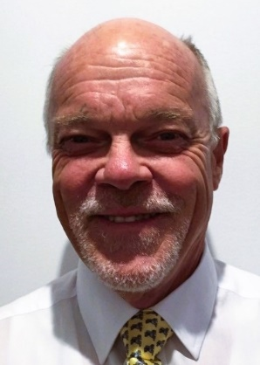 |  | Dr Bob Jackson started in disability as a direct care staff member in a huge institution in NSW. In the 1970s he worked as a psychologist, institution superintendent, service manager and Regional Director with the State Disability Services Commission of WA.  From 1995, Dr Jackson has been closely involved with school inclusion, advising families, teachers, schools and education systems on the rationale and practicalities of inclusion. Dr Jackson was contracted by the Federal Government to review disability discrimination in education in Australia and other countries and has appeared as an expert witness in several discrimination cases since the early 1990s. Currently Dr Jackson is working as a private consultant in disability and education but remains an Adjunct Associate Professor at Curtin University. He was a co-founder of All Means All, and a foundation member of the Australian Coalition for Inclusive Education (ACIE) and the teacher professional organisation Inclusive Educators Australia.
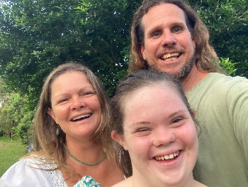 |  | Lyla, Renee & Aaron Brown will join the inclusive education workshop on Friday. Together they will share their experience of Lyla attending local schools, their learnings and the impact this has had on their lives.  Lyla, her mum Renee and dad Aaron along with her brother Noah live on the Sunshine Coast. Lyla is 20 years old and attended her local primary school and high school with her brother. Lyla graduated from high school in 2021 and is living her best life. Lyla is learning to become a dog trainer and has recently held her first art exhibition. Lyla works at a local café, enjoys going to karaoke at the local pub on a Friday night and has aspirations of becoming a famous singer. Together Renee and Aaron run their own small business. Aaron is a machine operator, and Renee works as a teaching assistant and is studying to be a primary school teacher. The Brown family have been connecting with CRU for many years and have supported other families in advocating for their child’s inclusion at school.

 |  | Employment
 |  | 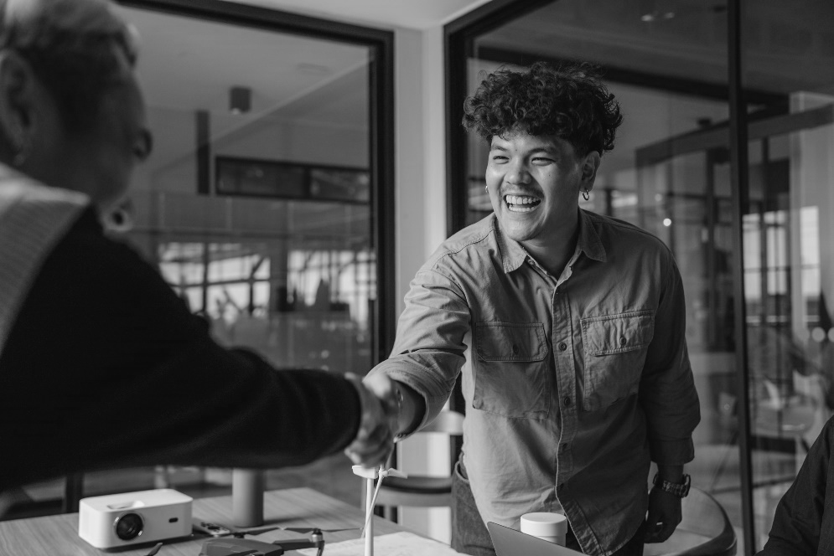
FRIDAY WORKSHOP  14th March 2025 |  | Getting a Job – stories of where to start and what it takes!  Drawing on real life examples this workshop will show that having a job is possible and that there are different ways to achieve the benefits and satisfaction of having paid employment. Four speakers will address this, sharing stories of what is possible in Queensland, other Australian states and overseas.  Learning Objectives  When undertaken as training for people with disability, family members, carers or supporters this workshop will:  - Build capacity to design, find and maintain employment in the open labour market, including self-employment.  - Build capacity, understanding and skill to support a person with disability to transition from school to employment or for adults to transition to new employment opportunities.

 |  |  | Meet Your Presenters
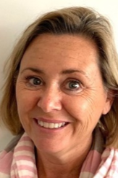 |  |  | Helen Neale works for Community Living Project (CLP) in SA as the Project Lead of a 5-year ILC Grant (Information, Linkages and Capacity Building (ILC)) called ‘Discover Micro Enterprise – Exploring Possibilities’.  Helen’s son, Tom, owns a small business known as Ground Control by Major Tom. Helen is passionate about inspiring people with disability to have high expectations about careers and work.
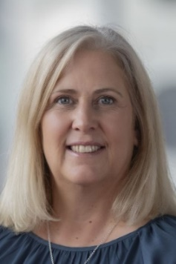 |  |  | Dr Jenny Crosbie is a Principal Industry Fellow at the Centre for Social Impact, Swinburne University, Melbourne. Jenny has supported people with disabilities to be included in all aspects of community life for over 35 years, with a particular interest in school to work transition for young people with intellectual disability. Jenny’s research has a strong lens on the ecosystem in which young people with disability, families, service providers, employers and government are operating. In this presentation Jenny will look at the ‘big picture’ and discuss the barriers and enablers to employment in the Australian context. She will also share stories of national and international initiatives.
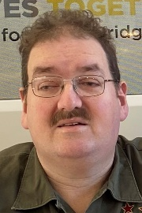 | 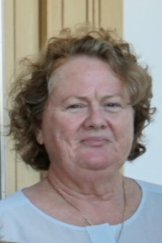 |  | Rohan & Jenni Pidgeon: Rohan Pidgeon is the owner of Rohan Pidgeon Enterprises in Toowoomba in Southwest Queensland, selling woodwork, arts and crafts. Rohan will present with his mother Jenni Pidgeon and friend Paul Taylor on Rohan’s career so far and plans for future business ventures. This story starts in Clermont in Central Queensland, when Jenni was on the management committee of Queensland Parents for People with a Disability (QPPD). In the 90s Rohan did work experience at school, volunteered, and earned his first award-wage job. Rohan now works at his own business and lives in his own place in Toowoomba. This presentation includes the changing role of family in Rohan’s work life, Rohan’s work now, and how he makes business decisions with the assistance of his friend and business advisor Paul.
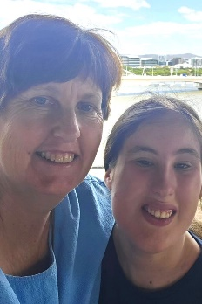 |  |  | Tracey Healy lives in Brisbane and is mum to 17-year-old Jess who is currently completing Year 12. Jess has a rare genetic condition that impacts her both physically and cognitively. As a passionate advocate for inclusion, Tracey is navigating the journey of future employment for Jess. The families vision focuses on customized employment solutions that highlight Jess’s strengths and interests, challenging traditional expectations and redefining what’s possible. During this presentation, Tracey will share insights into the journey to date and the family’s approach to planning for Jess’s future, exploring creative pathways that promote independence, confidence, and success in the workforce.

 |  | Supported Decision Making
 |  | 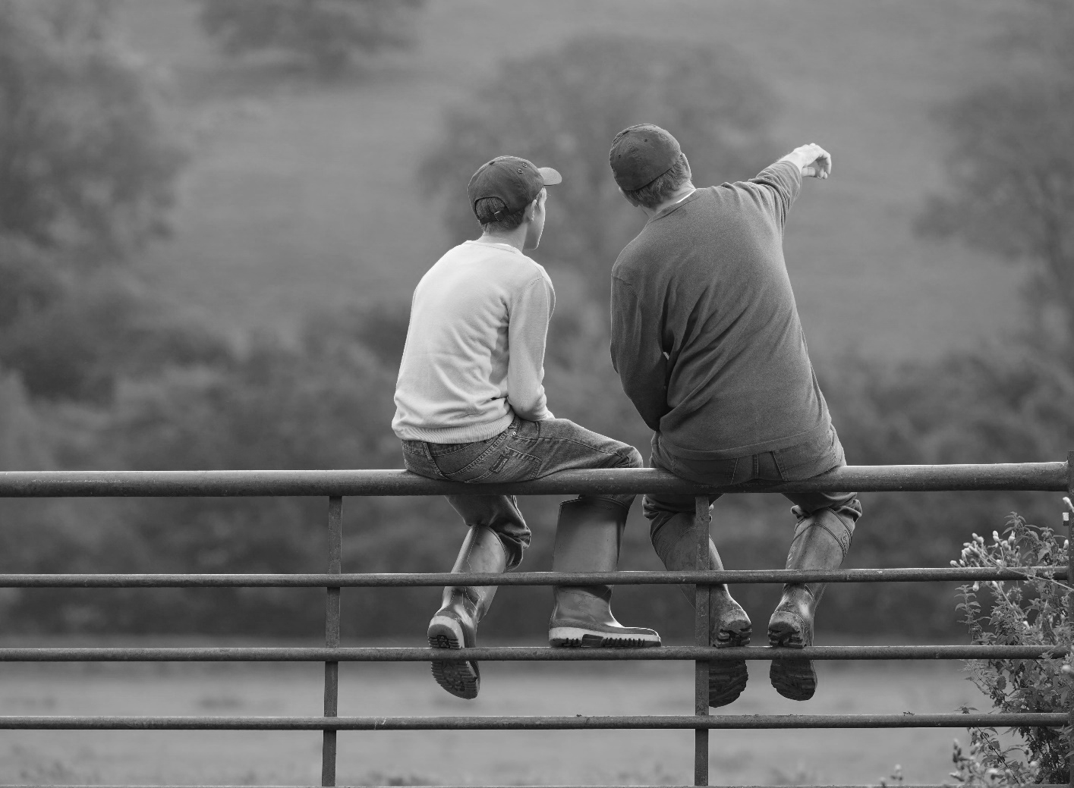
FRIDAY WORKSHOP  14th March 2025  Note: Repeat session  on Saturday, with different  co-presenters each day! |  | Voice, Rights and Risk: Exploring Supported-Decision Making  This workshop grounds supported decision-making in human rights and explores two complex areas of supported decision making in practice: supporting communication and enabling risk.  How do we ensure that each person is supported in the way they need to make decisions and to have their will and preferences understood, respected and translated into action?  The workshop also explores enabling risk. Taking risks is a normal and exciting part of life and an important part of learning about ourselves and the world. As risk comes with the possibility of negative consequences, how best to support a person to make risky decisions?  Learning Objectives  When undertaken as training for people with disability, family members, carers or supporters this workshop will:  - Build capacity to support increased independence and life skills including lifelong learning through understanding and maximising supported, rather than substitute, decision making.  - Build capacity and skills to develop, or support others to develop life skills including decision-making, problem-solving and lifelong learning.

 |  | Meet Your Presenters
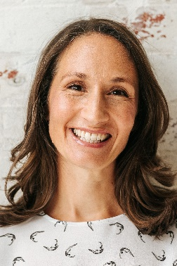 |  | Dr Michelle Browning is passionate about supporting individuals and organisations to develop their skill in the practice of supported decision-making. She is a Churchill Fellow and has completed doctoral research into the practice in Canada.  Michelle has been involved in developing, implementing and evaluating supported decision-making projects across Australia. She facilitates training, practice groups and supervision for supporters wanting to build their confidence as practitioners. She also provides training for decision makers wanting to understand more about decision making and their rights.
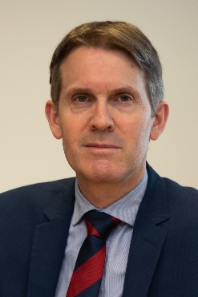 |  | John Chesterman is the Queensland Public Advocate. A lawyer and historian by training, John has expertise in the fields of human rights, guardianship, supported decision-making, powers of attorney and elder abuse. Prior to taking up his current position John was Victoria’s Deputy Public Advocate. He has previously undertaken a Churchill Fellowship on the topic of adult safeguarding, and his books include, as co-author, The politics of human rights in Australia (CUP).
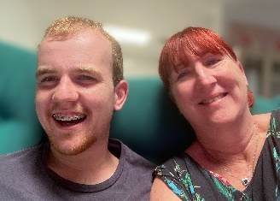 |  | Taylor & Hazel Lloyd will present on Taylor’s experiences as a decision maker, with a focus on support for communication. They will share what works best for Taylor, how they worked this out and how they resource people in Taylor’s life to understand and facilitate Taylor’s decision making.  Taylor is 18 and lives in Brisbane with his Mum, Dad, Nanna, Sister and dog. Taylor is currently a job seeker, with his family supporting him to explore customised employment as a pathway to meaningful work. He enjoys regular gym sessions, Pickleball, 10 Pin bowling league, volunteer work, model train club, playing Keno, and several game shows including The Chase. His favourite Chaser is The Professor, who is yours?!  Hazel is Taylor’s mum and is a passionate advocate for authentic inclusion. Hazel wants Taylor to experience a typical, regular life which includes real connection and belonging in his local community. Hazel believes that communication is key for all people and is always considering how to support Taylor to express himself and his wants and needs, and how to ensure that those around him are best equipped to do this as well.

Behaviour & Sensory
& Movement Differences
 |  | 
FRIDAY WORKSHOP  14th March 2025  Note: This workshop is complementary to Saturday’s workshop on this topic. |  | Looking Behind the Behaviour: Part A -  A holistic approach to exploring sensory and movement differences  Sorting out the complex mix of behaviour, sensory processing, movement difference, trauma and other challenges can make it possible to truly understand a person’s needs and assist them to have the best life possible. This workshop will deepen and clarify knowledge and understanding of these factors and how they can impact an individual.  Learning Objectives  When undertaken as training for people with disability, family members, carers or supporters this workshop will:  - Build capacity and understanding of impacts of disability or differences on a person and their behaviour which, when not well understood and supported, are an impediment to social and community participation and living as independently as possible.  - Build capacity and skills to develop, or support others to develop life skills to support increased independence.

 |  | Meet Your Presenters
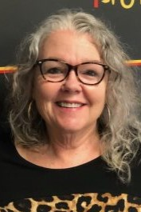 |  | Ann Greer has over 30 years’ professional experience working with people whose behaviours are seen as challenging. As well as drawing on the teachings of Donnellan, LaVigna and Willis, most of her learning and understandings have come from her greatest teachers, people with disabilities themselves.  Ann works with people with disability and their families across Australia to develop creative options and understand what’s possible in making a good life. Ann is the mother of three adults, two of whom live with disability.
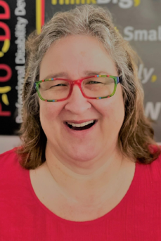 |  | Joyce-Lyn Smith has 28 years’ professional experience supporting people with complex support needs in a variety of environments and settings. Living in Townsville, she is the Clinical Director at PoDDSS (Professional Disability Development Supports & Services) and has previously worked in the Intensive Behaviour Support Team with the Queensland government.  Following completion of the mentoring program with Professor Anne M. Donnellan, University of San Diego and Martha R. Leary (SLP), Nova Scotia in 2009, Joyce-Lyn collaborated with Learning Disability & Mental Health Nurse Karl Jacks to develop their workshop on sensory and movement differences.
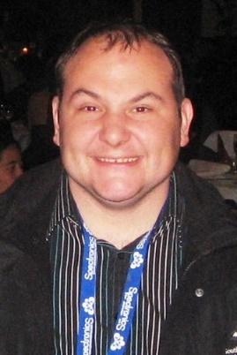 |  | Rodney Mills: For many years Rodney was put in the ‘too hard basket’ because he was exhibiting ‘challenging behaviours’ on an almost daily basis.  Today Rodney is a professional consultant, teacher and trainer, who worked for 10 years in a paid job at the organisation that used to support him.  Rodney runs his own business and presents at conferences and workshops. In his work he shares insights about living with Autism and OCD and how he has gradually built a meaningful life where he is no longer defined by these labels and by ‘behaviour’.

 |  | Respectful Support
 |  | 
FRIDAY WORKSHOP  14th March 2025 |  | Respectful Support – this collaborative workshop led by three managers of small to medium sized Queensland services, invites workers and organisational leaders to engage in collaborative dialogue. There will be short presentations that get to the nitty gritty of what it takes to work with people respectfully and the importance of values and mindsets in this work. It’s an opportunity to explore the question of growth and why size matters with these arrangements and to think about sustainability.  The presentations will be interspersed with time for discussion giving opportunities to exchange ideas and learn from varied perspectives. This session is perfect for those looking to deepen their practice and contribute to a respectful, values-driven approach to support.  Learning Objectives  When undertaken as training for people with disability, family members, carers or supporters this workshop will:  - Build capacity and skill to recognise high quality formal support and utilise formal support in sustainable arrangements.  - Develop capacity including through peer learning, drawing from the experiences of people with disability and families, workers and coordinators around life transition points, life skills and greater independence in the community.

 |  | Meet Your Presenters
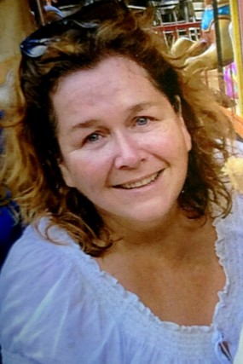 |  | Leanne Burke has worked at Staffing Options since 2006, establishing the host agency for self-directed support and has collaborated in transitioning the principles of self-direction and shared management into the services provided under the NDIS.  Prior to this she worked for 12 years in coordination roles for small family and user-governed services including Homeswest and Lifestyle Options Inc.
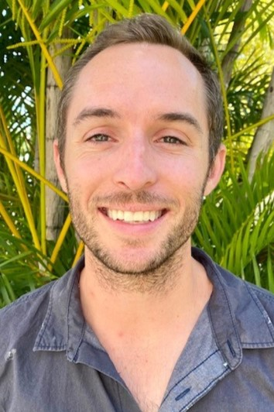 |  | Ricky Esterquest founded Towards Better in Townsville in 2020. He is the Principal Community Development Worker there.  With over 17 years’ experience in disability and community services in Queensland, Ricky’s main priority is the inclusion of individuals with a disability in work, learning, and other valued social roles. Originally from Chicago, Ricky moved to Townsville nine years ago and continues to live there with his wife and two boys.
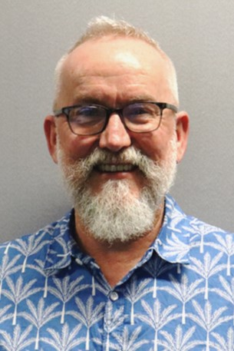 |  | Matt Stone has worked in individual and family support services for people with disability since the late 80s. He is currently a manager at Staff Connection and works in the Gold Coast and Scenic Rim areas. Social Role Valorisation (SRV) has been a major influence on Matt’s work and his thinking.

