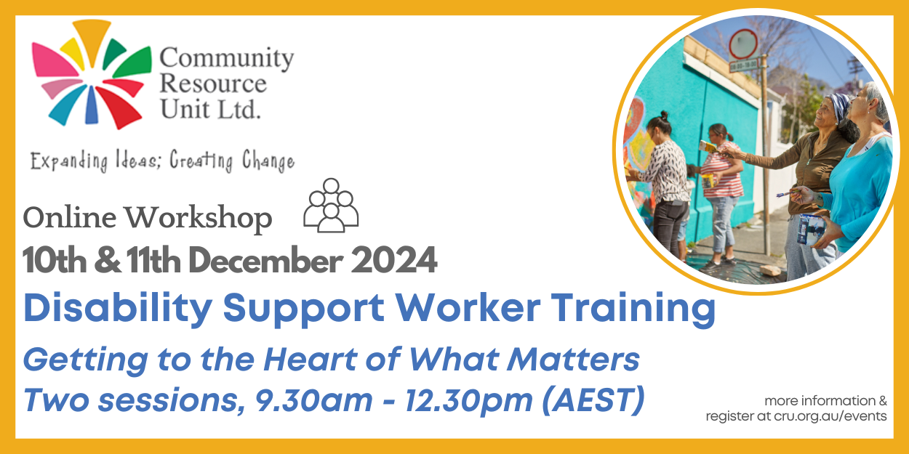

Getting to the Heart of What Matters: An Online Workshop for Support Workers
Community Resource Unit Ltd

Online – Tuesday 10th and Wednesday 11th December 2024

Presenter: CRU Consultants

Cost: $150

Course Outline
- Paid staff can make a significant contribution to the life of a person with disability – enabling the person to live a rich life and pursue their unique goals and dreams. What lies at the heart of the role is, however, frequently invisible. When we fall into the habit of talking about ‘hours’, tasks, routines, and schedules, it’s easy to be distracted from what really matters about supporting people well.
- This two-part interactive workshop focuses on the values that underpin and drive support, with an emphasis on valued roles and community belonging.
- Participants must attend both sessions and complete brief tasks prior to each session. This is a participatory and live online workshop series, and as such which will not be recorded.

Who is this workshop for?
- This training is for support workers who are directly assisting a person with disability to live a good life in community.
- The online workshop is participatory with lots of opportunities to engage in activities – participants are expected to use their microphone and keep their video on.
- If you or your organisation wants to register more than four workers, please contact CRU to discuss this.

Topics covered
- The purpose of support work
- Values, beliefs and assumptions
- Getting to know the person
- Valued roles
- Promoting friendships & relationships
Note: The content covered in this workshop is equivalent to Day 1 of our two-day face to face Getting to the Heart training. Day 2 content will next be offered in early 2025.
[Support] requires a certain humility on the part of staff, letting go of control, a willingness to follow rather than lead.” Susan Stanfield

About the Presenters
- Our experienced disability consultants and presenters bring a wealth of experience in supporting people with disability and families in their efforts towards a good and ordinary life.
- The content of our workshops is brought to life through the sharing of examples and personal stories that illustrate how the ideas can be implemented.

Additional Information
- Enquiries: For more information, please call us or visit the "Fee for Service" page on the CRU website
- Learning Objectives: Please refer back to our website for Learning Objectives for this workshop. They should assist NDIS participants and their supporters to determine if they relate to the participant’s goals.
- Fees & Cancellation: If price is a barrier then please contact us to discuss your options further. To see our cancellation policy please visit our website.

Using Your NDIS Funding at CRU
For self-managing and plan-managed NDIS participants, see the Learning Objectives on the event's page. You can decide if this is a reasonable and necessary support to help you (or your family member) achieve their goals.

Event and Venue Details

Date and Time
- Tuesday 10th and Wednesday 11th December 2024
- 9.30am to 12.30pm

Venue details
- The workshop will take place online and the link to join will be emailed prior to the event.

Cost
- $150 per person

Purchase Tickets
- Please register and book your tickets through the following link:
TO UPDATE LINK HERE

RSVP
- Registrations close on Monday 2 December 2024

Cancellations
- CRU’s cancellation policy is on our website.
- Please use the following link: http://cru.org.au/about/policies/#cancellation

About Community Resource Unit Ltd.
- CRU has a 35-year track record of working across Queensland to help people with a disability take control of their lives and take their place in their community.

Contact Community Resource Unit Ltd.

Phone
07 3844 2211

Email
cru@cru.org.au

Website
www.cru.org.au

Address
Level 2, 43 Peel Street. South Brisbane. Queensland.

ABN/ACN
ABN:16 143 460 250 ACN: 617 860 009

