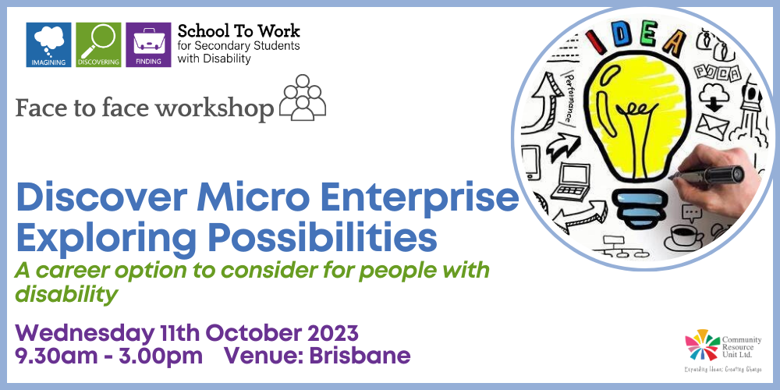

Discover Micro Enterprise – Exploring possibilities
A career option to consider for people with disability

By Community Resource Unit Ltd

Wednesday 11th October 2023 from 9.30am – 3.00pm (please arrive from 9AM to sign-in)

Cost: $35 per person with disability or the family members and $50 workers, allies and friends

About the Workshop
- Guest speaker Helen Neale from Community Living Project (CLP) in South Australia will facilitate two sessions, the first event being an information presentation/ seminar and the second session a more in-depth workshop for those who are interested in this employment pathway or have an idea for their small business.
- Helen will speak about establishing a Micro Enterprise, why it can be a wonderful career option, and share stories about Enterprise Owners and their businesses.
- She will explain:
- What a Micro Enterprise is and some examples of local Micro Enterprises
- The benefits of considering Micro Enterprises
- The principals which guide South Australia’s Community Living Project’s Micro Enterprise project
- Tips for using NDIS funding to set up a Micro Enterprise
- How to establish a Micro Enterprise.

The day will include two separate sessions (Attendance at the morning session is a prerequisite to attending the afternoon session)

Session 1: Introducing Micro Enterprise 9:30am - 12:30pm
- This introduction presentation will explore:
- The significance of having valued roles and contributing to your community
- The importance of work in all our lives
- The positive change in people’s lives from owning an enterprise
- How NDIS funding can support this option

Who should attend session 1?
Open to all – Families and workers.

Session 2: Practical Workshop 1pm - 3pm
- This workshop session is for people who are ready to explore how a micro enterprise could work for them. We will take a deeper dive into exploring your ideas and passions as the first step and ‘discovery’ of the possibilities.

Who should attend session 2?
This workshop is specifically for people with disability, their family and allies.

About the Presenter
- Helen Neale works for community Living Project (CLP) in SA as the Project Lead of a 4-year ILC Grant called “Discover Micro Enterprise – Exploring Possibilities”. Helens’ son, Tom, owns a small business known as Ground Control by Major Tom. Helen is passionate about inspiring people with disability to have high expectations about careers and work.

Event Details

Date and Time
Wednesday 11th October 2023 from 9.30AM – 4.30PM (please arrive from 9AM to sign-in)

Venue Details
Victoria Park, 309 Herston Road, Herston Queensland 4006

Cost
- $35 per person with disability or their family members
- $50 per person for workers, friends and allies

Tickets
- Please register and book your tickets through the following link: https://events.humanitix.com/micro-enterprise-oct2023

RSVP
- Registrations close on Wednesday 4th October 2023

Cancellations
- CRU's cancellation policy is on our website. Please use the following link: http://cru.org.au/about/policies/#cancellation

About Community Resource Unit Ltd.
- CRU has a 30 year track record of working across Queensland to help people with a disability take control of their lives and take their place in their community.
- Community Resource Unit (QLD), Resourcing Inclusive Communities, an initiative of Family Advocacy (NSW) and Imagine More (ACT) are working together on a three-year project called ‘School To Work’.
- 'School To Work’ aims to inspire, increase confidence and motivate students with disability to seek and find meaningful employment with the help and support of their family and community.
- The project is being provided as part of the Community Inclusion Capacity Development program through The Department of Social Services.

Contact Community Resource Unit Ltd.

Phone
07 3844 2211

Email
cru@cru.org.au

Website
www.cru.org.au

Address
Level 2, 43 Peel Street, South Brisbane, Queensland, 4101.

ABN/ACN
ABN:16 143 460 250 ACN: 617 860 009

