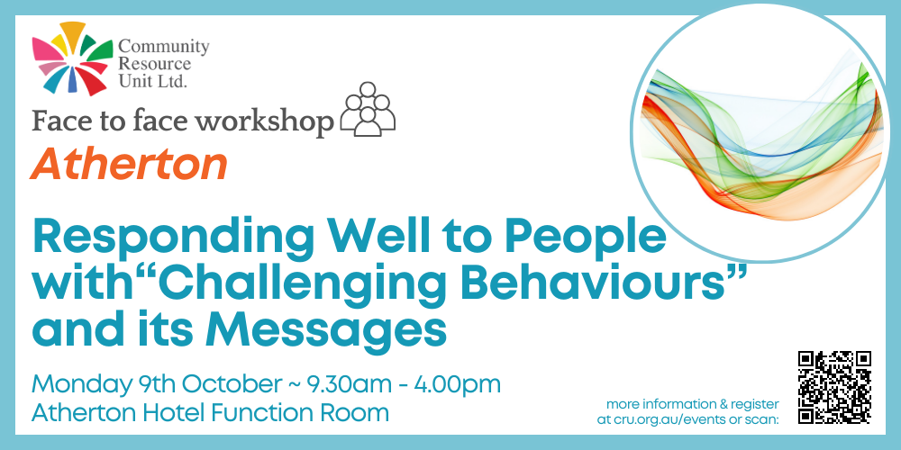

Face to face workshop in Atherton: Responding Well to People with “Challenging Behaviour” and its Messages.
Community Resource Unit Ltd

Atherton workshop: Monday 9th October 2023 from 9.30AM to 4.00PM

Presenter:
Ann Greer

Cost:
$50 per ticket for People with Disability and Family members, $150 ticket for Workers, Friends and Allies

About the Workshop
- This workshop will encourage participants to understand more about the situations in which people with ‘challenging behaviour’ find themselves and to explore how they can best respond to support the person.
- Presenter Ann Greer will cover ways to develop strategies with the person, so that, regardless of the level of their disability, they can better understand the motivations, effects and consequences of their behaviour.
- This workshop will involve information sharing, practical tips and strategies and learning through stories. It will not provide a recipe to ‘fix’ the person.

This workshop covers
- Defining and describing challenging behaviour
- Communication and its role in behaviour
- Understanding our part in the behaviour of others
- Practical steps for ‘making a start’

About the Presenters
- Ann Greer: Ann Greer has over twenty years’ professional experience working with people whose behaviours are seen as challenging.
- As well as drawing on the teachings of Donnellan, LaVigna and Willis, most of her learning and understandings have come from her greatest teachers, people with disabilities themselves.
- Ann works with people with disability and their families across Australia to develop creative options and understand what’s possible in making a good life.
- Ann is the mother of three adults, two of whom live with disability.

Who Should Attend
- This workshop will be of interest to anyone supporting a person labelled as challenging – whether as a parent, family member, friend, or in a work role.

Event Details

Date and Time
- Monday 9th October 2023
- The workshop runs from 9:30AM to 4.00PM, but please arrive from 9AM to sign-in

Venue details
- Atherton Hotel Function Room, 90 Main Street Atherton QLD

Cost
- $50 per ticket for people with a disability and family members
- $150 per ticket for workers, friends, and allies
- The cost to attend includes lunch and light refreshments throughout the day
- This event is partly subsidised by the Commonwealth Department of Social Services through an Information, Linkages and Capacity Building (ILC) grant. If cost is a barrier to attending, please contact CRU to discuss.

For self-managing and plan-managed NDIS participants, see the Learning Objectives on the event's page. You can decide if this is a reasonable and necessary support to help you (or your family member) achieve their goals.

Tickets
Please register and book your tickets through the following link:
https://events.humanitix.com/atherton-responding-well-oct23

RSVP
- Registrations close on 1st October 2023

Cancellations
- CRU's cancellation policy is on our website. Please use the following link: http://cru.org.au/about/policies/#cancellation

About Community Resource Unit Ltd.
- CRU has a 30 year track record of working across Queensland to help people with a disability take control of their lives and take their place in their community.

Contact Community Resource Unit Ltd.

Phone
07 3844 2211

Email
cru@cru.org.au

Website
www.cru.org.au

Address
Level 2, 43 Peel Street. South Brisbane. Queensland.

ABN/ACN
ABN:16 143 460 250 ACN: 617 860 009

