Is the

Adjustment

Inclusive?

A guide to

thinking about

reasonable

adjustments

which best

promote

inclusion

Families for
Inclusive Education
October 2020 (Updated)
Inclusive Education

Is the Adjustment Inclusive, or Not?

A guide to thinking about reasonable adjustments which best promote inclusion
A “Reasonable Adjustment” is a change or action to help a student with disability take part in education on the same basis as other students.
Adjustments can be made across the whole school (eg ramps into school buildings), in the classroom (eg adapting teaching methods) or to address individual student need (e.g. providing Auslan interpreter or personal care support). The school should provide adjustments in consultation with the student and/or their parents, guardians and carers.
Most reasonable adjustments do not require additional funding or support.
The obligations also apply to the student’s participation outside the classroom e.g. excursions, and extra-curricular involvement.

A reasonable adjustment is a change or action to help a student with disability take part in education on the same basis as other students.

An adjustment is reasonable… if it balances the interests of all parties affected. (Disability Standards for Education 2005) This reads as legal jargon to many parents, but points to a process of negotiation. It is an important and necessary legal requirement via the Disability Standards for Education (DSE) that students and their parents/carers are consulted when reasonable adjustments are being determined.

The process of negotiation does not diminish the legal obligation to provide adjustments which are “reasonable” and which allow the student to participate “on the same basis” i.e. the school should not claim that simple and effective adjustments are not possible.
Parents who understand their child’s right to access an inclusive education, and the evidence for the benefits of such, will want to advocate for INCLUSIVE adjustments during this consultation process.
Unfortunately, many adjustments currently made every day for students with disabilities in schools, are less than inclusive. These ‘default’ adjustments can result in a lower quality education, or even stigmatise a student amongst their peers while leading to reduced independence and diminished self-concept.
Why are adjustments commonly offered by schools and advocated for by parents, often less than fully INCLUSIVE?
After a century of educating students with disabilities in segregated settings, Queensland began INTEGRATING students with disabilities into mainstream classrooms in 1986. https://education.qld.gov.au/about-us/history/chronology-of-education-in-queensland
Many current parents of students with disabilities, were, at that time, the non-disabled peers to students with disabilities who were being INTEGRATED into ‘mainstream’ schools with varying levels of success, and with adjustments and supports that were reflective of the view of disability of the time.
It is understandable then that parents, and educators, who grew up in INTEGRATION default to adjustments and supports that are NOT INCLUSIVE. The purpose of recognising INCLUSIVE adjustments is so both parents and educators can strive for better in the future.
How can a parent ensure they are asking for adjustments that are INCLUSIVE?
Beginning with this proposed definition can help:

Inclusive reasonable adjustments are strategies that support students in the most ‘ordinary’ way, and in ways that same age peers value.
3Q’s
?
?
?
When considering an adjustment, educators can ask
- Have I put the student at the centre of the decision making, ie have I asked them what adjustment or support they prefer?
- Is it going to build the student’s confidence as an independent learner and contributor?
- Is it going to maintain or improve the student’s value amongst their peers?

These same questions may be helpful filters for families when they are consulted about planned adjustments.
Below are 6 scenarios where reasonable adjustments would need to be planned between school staff and the students and parents/carers.
You will likely find it easiest to think of the ‘default’, meaning a common option that you would have seen historically which remain common in many schools today. These default options are likely to be “segregation” or “integration”. So it is helpful to think further… what would INCLUSIVE options be?

Remember
- True inclusion can involve flexibility and creativity to begin with because it hasn’t been done before.
- Modern technology that is typically used by many children and adults can sometimes be the answer.
- Other times, it can simply be asking ourselves what support would make me feel more confident and valued.
- It is almost always a good idea to involve the student.
Where the student is unable to communicate about the supports that will suit them best (either due to age or communication limits), it is still worthwhile asking, while also paying attention to what has been successful previously, and other indicators of the student’s preferences.

Scenarios
Scenario 1 example
Year 6 – History and Social Sciences (HASS)
Three classes merge for a regular combined class activity. Mark can become frustrated with noisy environments or being with lots of people.
Common ‘default’ adjustments:
Mark works one-on-one with a teacher aide; Mark receives one-on-one supervision to monitor for any signs of not coping while engaging in class activity.

HOWEVER are these inclusive adjustments? Mark is in year 6, but has he been involved in the decision making? Are there supports/adjustments that would help Mark be included in a more typical way, in a way that builds his confidence as an independent learner, and this would at least maintain his value amongst his year 6 peers?

Inclusive adjustments could be:
Prepare Mark for the event in advance. Ask Mark what support would help: noise defenders; option for a break; visual schedule; work in a group with friends.

Scenario 2:
Year 4 – A two-day camp
The class needs to walk 20 minutes to the lake for a kayaking activity. Martha finds it difficult to walk this type of distance.
First ‘default’ reasonable adjustments that come to mind (remember, you probably see this still happening commonly today):

Now, are there adjustments that you think would be more inclusive?:
(think typical and valued, and go through the 3 questions on the previous page)

Now work through the same process with these other scenarios (an ‘answer sheet’ is provided at the end of this resource, but remember “inclusion is a process, there is no finish line” – you might be able to think of even better, more inclusive adjustments)

Scenario 3:
Year 8 – Lunchbreak
Judy is finding it difficult to engage in conversation with her friends and begins ‘acting out’ during some lunchbreaks. Other days, Judy sits alone and appears to be disengaging from her friendships.
First ‘default’ reasonable adjustments that come to mind (remember, you probably see this still happening commonly today):

Now, are there adjustments that you think would be more inclusive?:
(think typical and valued, and go through the 3 questions on the previous page)

Scenario 4:
Prep – Lunchbreak
Joe has been known to leave the Prep playground area during break times. Staff and parents are concerned about keeping him within school grounds.
‘Default’ adjustments that come to mind (you probably see this still happening commonly today):

Now, adjustments that you think would be more inclusive?:
(think typical and valued, and go through the 3 questions above)

Scenario 5:
Year 12 – Maths
Damien has been assessed at a year 2 level for Maths. He’s becoming increasingly disruptive in the regular year 12 Maths class.
÷ ± ×
‘Default’ adjustments that come to mind:

Adjustments that you think would be more inclusive?:

Scenario 6:
Year 3 – English
Alex has been identified with reading difficulties.
‘Default’ adjustments:

Adjustments that would be more inclusive?:

When families can distinguish between inclusive and non-inclusive adjustments, it can help them to advocate for better inclusive practices.
Sometimes families and schools will disagree about what is “reasonable” and “what is inclusive”, and sometimes it will take sustained advocacy to get to better school inclusion.
Along the way, families may find they need to negotiate through compromise and steady, polite but firm advocacy - while always aiming for better for their sons and daughters with disability.

SCENARIO ‘ANSWERS’
Scenario | Possible Reasonable Adjustments
 | Non-inclusive Options | Inclusive Options
Year 6 – HASS  Three classes merge for a regular combined class activity. Mark can become frustrated with noisy environments or being with lots of people. | - Mark works one-on-one with a teacher aide.  - Mark receives one-on-one supervision to monitor for any signs of not coping while engaging in class activity. | - Prepare Mark for the event in advance.  - Ask Mark what support would help: noise defenders; option for a break; visual schedule; work in a group with friends.
Year 4 – A two-day camp  The class needs to walk 20 minutes to the lake for a kayaking activity. Martha finds it difficult to walk this type of distance. | - Martha is driven to the site by herself when it is convenient for the staff.  - Martha doesn’t go kayaking and stays at camp with an aide. | - Martha can choose friends to be transported with, and they join the rest of the class 200 metres (comfortable distance for Martha) from the lake so they can walk the remaining distance with the class.
Year 8 – Lunchbreak  Judy is finding it difficult to engage in conversation with her friends and begins ‘acting out’ during some lunchbreaks. Other days, Judy sits alone and appears to be disengaging from her friendships. | - ‘chill out zone’/sensory room set up for Judy to attend | - Judy and year 8 friends are asked about things they are interested in – clubs are set up at lunchtimes around these ideas. (craft, games, sports, etc.)
Prep – Lunchbreak  Joe has been known to leave the Prep playground area during break times. Staff and parents are concerned about keeping him within school grounds. | - Lunch in ‘the unit’ or separate area; lunch with adults; high vis vest | - Install pool fencing around the Prep area and school grounds – will improve safety of all students as well as any visiting younger siblings at school events  - Consider if Joe is trying to access something, or leave behind something else– can this be addressed?  - Explicitly teach all Prep students the boundaries of their play area, and to watch out for each other; many little eyes can be more effective than 2 adult ones.
Year 12 – Maths  Damien has been assessed at a year 2 level for Maths. He’s becoming increasingly disruptive in the regular year 12 Maths class. | - Doing year 2 Maths sheets | - Deliver age-appropriate material on same topic as what the rest of the class is doing; use supports to assist with content learning and application, that may also assist other class members, eg. task cards, using scientific calculator; using YouTube to support learning
Year 3 – English  Alex has been identified with reading difficulties. | - Alex is withdrawn for an hour 3 times a week for reading lessons. | - Classroom teacher to work in conjunction with learning support teacher in-class to identify strategies that will help Alex and possibly others.  - Reading skill building is balanced with strategies that support inclusion eg. text to speech software, audiobooks

Whether you are a student, family member, educator, school leader, other professional, or a community member interested in inclusive education, it is helpful to keep learning about inclusive education.
On CRU’s ‘Families for Inclusive Education’ resource site, you will find resources on what quality inclusive education looks like in practice, including research on what works, laws and policies on inclusion, and current approaches to inclusion in class, in the playground and in all aspects of school life.
You will also find stories from families and educators pursuing inclusive education and practical tips on the “how” of successful inclusion and parent advocacy.
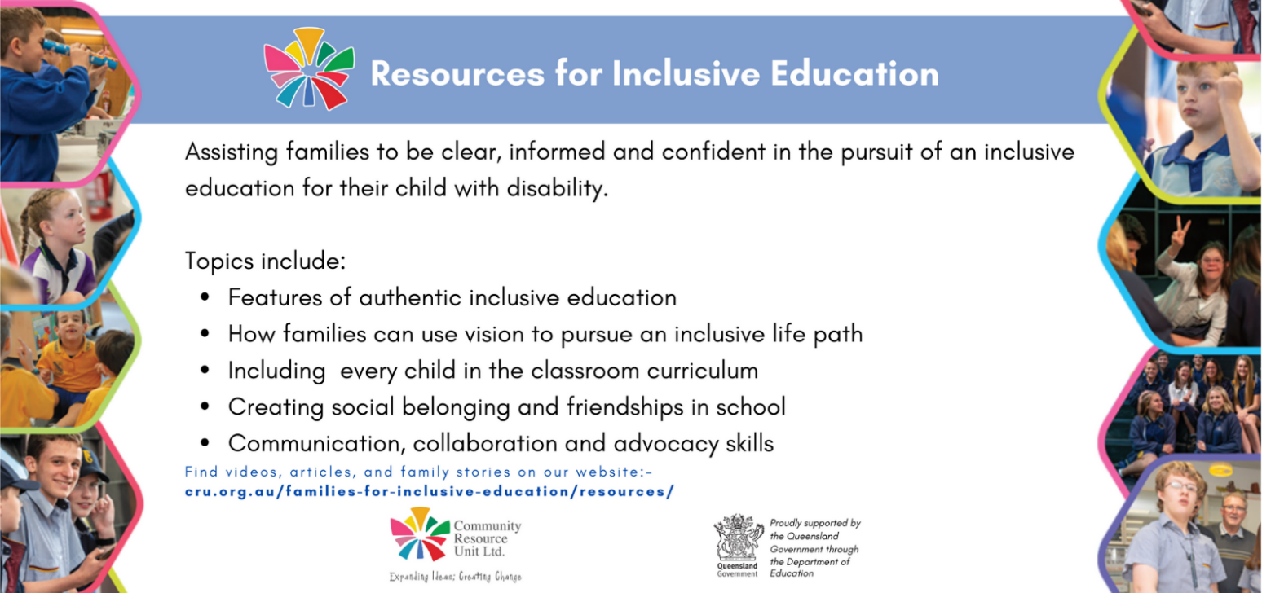
cru.org.au/families-for-inclusive-education/resources/
Community Resource Unit Ltd
ABN 16 143 460 250 ACN 617 860 009
Level 2, 43 Peel Street, PO Box 3722, South Brisbane QLD 4101
p: 07 3844 2211 f: 07 3844 3400 e: cru@cru.org.au www.cru.org.au

