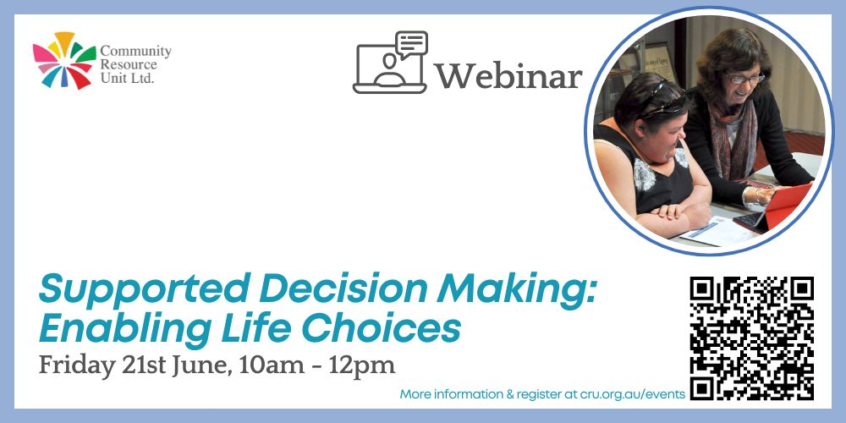

Supported Decision Making: Enabling Life Choices webinar
Community Resource Unit Ltd

Friday 21st June, 2024.

Cost
$35 per webinar for people with disability and family members. $75 per webinar for workers, friends and allies.

About the Webinar
Everybody needs and seeks help to make decisions from time to time. Yet for many people with disability, the right to make choices about their own lives is denied to them, or not supported well.
Presented by Citizen Advocate and Decision Coach, Jenny Smith, and drawing on her decades of experience, this webinar is an introduction to the principles and processes of true supported decision making.
We all learn and grow through the decisions we make. Instead of making decisions for a person, ensuring they have the support and information they need to make decisions in everyday life, and the support to learn from their decisions helps people become wiser and better decision makers.
Whilst we encourage you to join us live at the time if you can, this webinar will be recorded and be available to watch for 14 days after the event.

Who Should Attend
For people with disability, their family members, friends, allies and workers who assist a person in decision-making, or want to understand the fundamentals of supported decision making.

Event Details

Date and Time
- Friday 2^{1st} June 2024 10am to 12pm

Location
- Online

Cost
- $35 per webinar for people with disability and family members
- $75 per webinar for workers, friends and allies.
- This event is partly subsidised by the Commonwealth Department of Social Services grant. If cost is a barrier to attending, please contact CRU to discuss.

Tickets
Please register and book your tickets through the following link:

https://events.humanitix.com/supported-decision-making-enabling-life-choices-webinar

RSVP
- Registrations close on Wednesday 12th June

Cancellations
- CRU's cancellation policy is on our website. Please use the following link: http://cru.org.au/about/policies/#cancellation

About Community Resource Unit Ltd.
- CRU has a 35-year track record of working across Queensland to help people with a disability take control of their lives and take their place in their community.

Contact Community Resource Unit Ltd.

Phone
07 3844 2211

Email
cru@cru.org.au

Website
www.cru.org.au

Address
Level 2, 43 Peel Street. South Brisbane. Queensland.

ABN/ACN
ABN:16 143 460 250 ACN: 617 860 009

