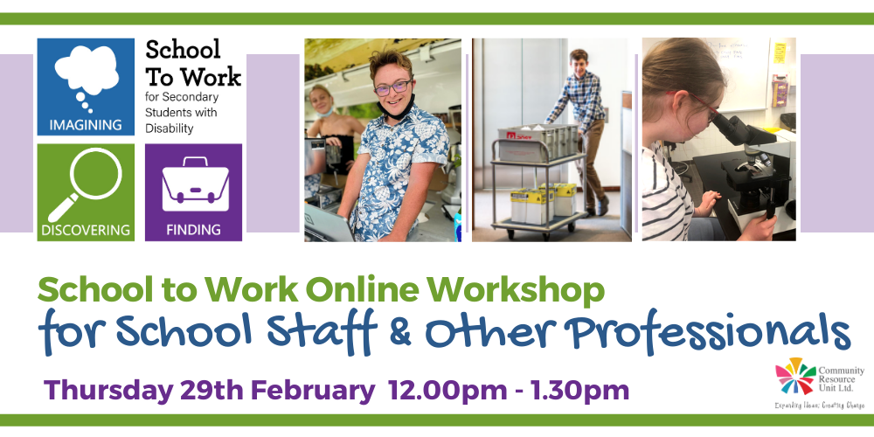

School to Work Online Workshop for School Staff & Other Professionals
Online Workshop
Community Resource Unit Ltd

Cost:
There is no cost to join the webinars, but registration is essential.

About the online workshop:
This online workshop is for all school staff and other professionals who work with secondary school students with disabilities.
It will complement what we share with families and is designed to equip teachers and support staff to partner with secondary students and their families in their quest for work.
Participants hear family stories of what is possible and work through some practical activities.
Please note this is a repeat of the online workshops offered in 2023.

This interactive workshop will cover:
- Positive Vision and high expectations for work
- The importance of the student voice
- A range of stories to highlight how to find or create work experience or work opportunities
- Identifying the conditions that help set up the young person for success in work
- Exploring what good employment support looks like
- Exploring what Customised Employment can offer
- Transitioning from school to work

Event Details

Date and Time
- Thursday 29th February 2024
- The onlineworkshop runs from 12.00PM to 1.30PM

RSVP
- RSVP by Tuesday 27th February

Venue details
- The webinar will take place online and the link to join will be sent to your registered email address prior to the event.

Cost
There is no cost to attend this webinar series, but registration is essential.

Tickets
Please register and book your tickets through the following link: https://events.humanitix.com/school-to-work-online-workshop-for-school-staff-and-other-professionals-2024

Who Should Attend?
This webinar is for all school staff and other professionals who work with secondary school students with disabilities.

What do I need to participate?
We will be using the video meeting platform Zoom to host the webinar.
You will need access to:
- a computer or iPad/tablet or smart phone with internet access;
- speakers/sound
Please contact us if you have any questions or concerns about your ability to participate.

Cancellations
- CRU's cancellation policy is on our website. Please use the following link: http://cru.org.au/about/policies/#cancellation

About Community Resource Unit Ltd.
About CRU:
For over 35 years, Community Resource Unit (CRU) has been working across Queensland to help people with disability take control of their lives and take their place in their community.
CRU (QLD), Resourcing Inclusive Communities, an initiative of Family Advocacy (NSW) and Imagine More (ACT) are working together on the ‘School To Work’ project.
'School To Work’ aims to inspire, increase confidence and motivate students with disability to seek and find meaningful employment with the help and support of their family and community.
The project is being provided as part of the Community Inclusion Capacity Development program through The Department of Social Services.

Contact Community Resource Unit Ltd.

Phone
07 3844 2211

Email
cru@cru.org.au

Website
www.cru.org.au

Address
Level 2, 43 Peel Street. South Brisbane. Queensland.

ABN/ACN
ABN:16 143 460 250 ACN: 617 860 009

