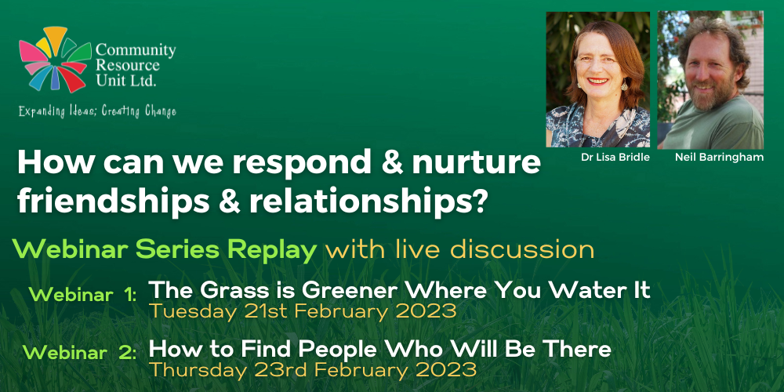

How Can We Respond and Nurture Friendships and Relationships?
Webinar series replays that include live discussions
Community Resource Unit Ltd

2 Webinars

Webinar 1: The Grass is Greener Where You Water It, Tuesday 21st February

Webinar 2: How to Find People Who Will Be There, Thursday 23rd February 2023

Cost:
Join for one or both webinars. Each webinar costs $35 per ticket for People with Disability and Family members, $75 ticket for Workers, Friends and Allies

About the Webinar Series
CRU is presenting a series of two webinars on How can we respond and Nurture Friendships and relationships in the lives of people with disability.
Many people with disability would like to have friends, yet have few people other than family or paid people that they can really count on. We may believe that if friendships and relationships do not come easily or happen ‘naturally’ then they are not possible at all. Our two presenters will show that it is possible to assist people to make friends and to develop a broad personal network – and that everyone’s lives are richer, safer and in some ways easier when we do.
So what does it take and what can we do to bring people and relationships into the life of a person with disability?

Webinar 1:
In this webinar, Lisa Bridle shares her experiences of how she started planning and building a social community around her son from the time he was young. Lisa explains the value of having an ambitious vision and how she seeks ordinary, valued experiences to build a web of relationships around Sean.

Webinar 2:
In this webinar Neil Barringham tells several stories of facilitating relationships and friendships in the lives of people with disability who were particularly isolated. Neil will share a framework for finding allies and explain what workers can do in supporting the development of freely-given relationships.

About the Presenters:
Lisa Bridle is a mother of 3 adult children and a social worker with a background in community development. She is Senior Consultant at CRU, leading CRU’s Families for Inclusive Education project which assists families to pursue a positive vision for school inclusion and life.
Since her son Sean was born, 27 years ago, she has been assisting Sean to lead an inclusive life embedded in his local community and surrounded by friendship and relationship.
Neil Barringham is a community worker who enjoys his rainforest back yard and neighbourhood. Neil has worked with others in his home and neighbourhood to facilitate inclusion and community supports. As an inclusion worker with “A Place to Belong”, Neil worked with allies over many years to build community-based supports and opportunities for participation with people who desire to belong. Neil has post graduate qualifications in community development and social work.
Each event will include a replay of the original webinar recorded in November 2022, followed by a facilitated discussion with the presenter providing time and scope to talk about key themes and to respond to questions. This discussion will not be recorded.
Everyone who registers will be sent a link to the webinar for a limited time after the event. As the discussion at the end will not be recorded, we really do encourage you to attend on the day if possible.

Event Details

Webinar 1:

Date and Time
- Tuesday 21st February 2023
- The webinar runs from 2.00PM to 4.00PM
- RSVP by Thursday 16th February

Webinar 2:

Date and Time
- Thursday 23rd February 2023
- The webinar runs from 2.00PM to 4.00PM
- RSVP by Thursday 16th February

Venue details
- The webinars will take place online and the link to join will be sent to your registered email address prior to the event.

Cost
Each webinar costs:
- $35 per ticket for people with a disability and family members
- $75 per ticket for workers, friends, and allies
- This event is partly subsidised by the Commonwealth Department of Social Services grant. If cost is a barrier to attending, please contact CRU to discuss.

Tickets
Please register and book your tickets through the following link:
https://events.humanitix.com/tours/how-can-we-respond-and-nurture-series-replay-with-live-discussion

Cancellations
- CRU's cancellation policy is on our website. Please use the following link: http://cru.org.au/about/policies/#cancellation

About Community Resource Unit Ltd.
- CRU has a 30 year track record of working across Queensland to help people with a disability take control of their lives and take their place in their community.

Contact Community Resource Unit Ltd.

Phone
07 3844 2211

Email
cru@cru.org.au

Website
www.cru.org.au

Address
Level 2, 43 Peel Street. South Brisbane. Queensland.

ABN/ACN
ABN:16 143 460 250 ACN: 617 860 009

