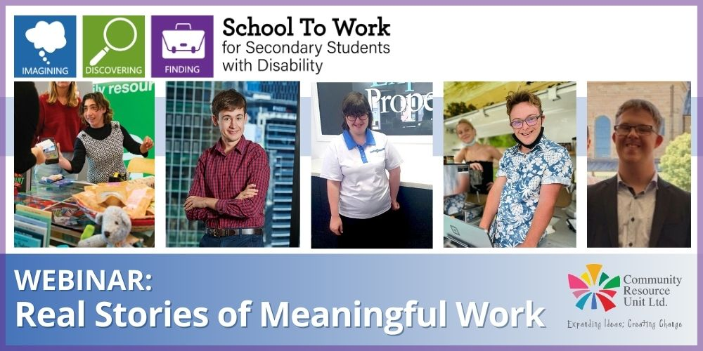

# Webinar Real Stories of Meaningful Work Community Resource Unit Ltd

# Thursday 19th October 2023 from 5.00pm – 6.30pm

# Cost:

Free

# About the Workshop

This webinar shares real local stories of five young people with disability who have found meaningful employment. Hear from the young person and their family about their job and the good things work brings to their life. Observe from other families what is possible, what it takes and why it is worth the effort. Parents share learnings and tips so you can take what is applicable to your young person and situation.

The webinar will include live Q&A. Please note this webinar will NOT be recorded or available to watch later, it is only available to watch live on the day.

# This interactive webinar will cover: • Family stories demonstrating meaningful work is possible for young people with disability • Strategies for finding and maintaining meaningful employment, and the role of family in this process • The importance of the young person being involved throughout the process and tailoring both the journey and the job to the individual

# Who Should Attend?

This webinar is for all Secondary school students (Year 7 – 12) with disabilities and their families. Supporters and allies are also welcome to attend.

# Event Details

### **Date and Time**

* Thursday 19th October 2023 at 5.00pm - 6.3-0pm

### **RSVP**

* Registrations close on Wednesday 15th October 2023

**Cancellations**

* CRU's cancellation policy is on our website. Please use the following link: <http://cru.org.au/about/policies/#cancellation>

# About Community Resource Unit Ltd.

* CRU has a 30 year track record of working across Queensland to help people with a disability take control of their lives and take their place in their community.
* Community Resource Unit (QLD), Resourcing Inclusive Communities, an initiative of Family Advocacy (NSW) and Imagine More (ACT) are working together on a three-year project called ‘School To Work’.
* 'School To Work’ aims to inspire, increase confidence and motivate students with disability to seek and find meaningful employment with the help and support of their family and community.
* The project is being provided as part of the Community Inclusion Capacity Development program through The Department of Social Services.

### **Contact Community Resource Unit Ltd.**

### **Phone**

07 3844 2211

### **Email**

[cru@cru.org.au](mailto:cru@cru.org.au)

### **Website**

[www.cru.org.au](http://www.cru.org.au)

### **Address**

Level 2, 43 Peel Street, South Brisbane, Queensland, 4101.

### **ABN/ACN**

ABN:16 143 460 250 ACN: 617 860 009