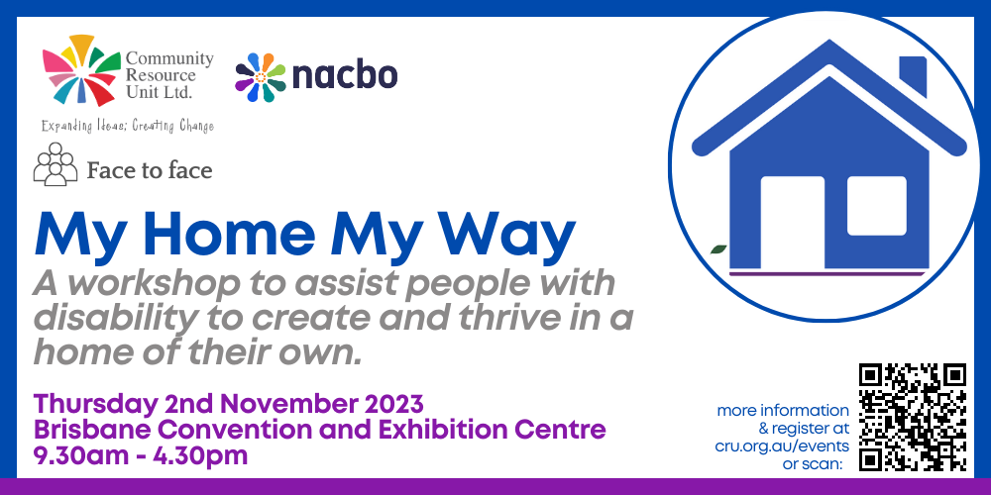

# My Home My Way – A workshop to assist people with disability to create and thrive in a home of their own

Presented by Community Resource Unit Ltd

## Brisbane Workshop – Thursday 2nd November 2023, 9.30 AM to 4.30 PM

## Presenters

CRU Consultants

## Cost

$50 per ticket for People with Disability and Family members, $75 ticket for Workers, Friends and Allies

## About the Workshop

* Home is a vital part of our lives. It provides us with security, privacy, comfort and control, and also reflects our identity, adulthood and deep sense of who we are and how we connect and belong in our neighborhood. Yet for many people with intellectual disability and autism, they have little control over the decisions that most others take for granted, as ‘home’ is designed by others.
* This workshop will explore individualised and innovative ways that people with a disability have created their own home, while getting the support they need.

## Topics covered will include:

* What does it really mean to have your own home and is it possible?
* Creating and holding a personalised vision for home,
* First steps to consider when creating a home of your own that’s unique to you,
* Living in your own home and settling in,
* A range of home options and creative supports,
* Addressing barriers, challenges and fears,
* Home as a part of community and neighbourhood,
* Setting up for long term safety and success, and
* Stories about people living in their own home with a range of supports

## Who Should Attend

* This workshop will be relevant to people with developmental disabilities, their families and supporters as they think through how they can move into and thrive in a home they can call their own.
* There will be a limited number of tickets available for workers.

## Other information

* This workshop is brought to you by CRU as part of the My Home, My Way initiative by National Alliance of Capacity Building Organisations (NACBO). The cost of this event is partly subsidised by a Department of Social Services Information, Linkages and Capacity Building grant. If cost is a barrier to attending, please contact CRU to discuss.
* CRU has capacity to offer assistance with travel costs for regional attendees. Please email [Danielle.mason@cru.org.au](mailto:Danielle.mason@cru.org.au) or call (07) 3844 2211 to discuss your needs.

# Event Details

## Date and Time

* Thursday 2nd November 2023
* The workshop runs from 9.30AM – 4.30PM, but please arrive from 9AM to sign-in.

## Venue

* Brisbane Convention & Exhibition Centre
* Glenelg Street, South Brisbane QLD 4101

## Cost

* $50 per ticket for people with a disability and family members
* $75 per ticket for workers, friends and allies

For self-managing and plan-managed NDIS participants, see the Learning Objectives on the event page. You can decide if this is a reasonable and necessary support to help you (or your family member) achieve their goals.

## Tickets

* Please register and book your tickets through the following link:
* [https://events.humanitix.com/my-home-my-way-nov23](https://events.humanitix.com/gold-coast-connecting-with-community)

## RSVP

* Registrations close on Thursday 19th October 2023

## Cancellations

* CRU's cancellation policy is on our website. Please use the following link: <http://cru.org.au/about/policies/#cancellation>

## About Community Resource Unit Ltd.

* CRU has a 30-year track record of working across Queensland to help people with a disability take control of their lives and take their place in their community.

# Contact Community Resource Unit Ltd.

## Phone

07 3844 2211

## Email

[cru@cru.org.au](mailto:cru@cru.org.au)

## Website

[www.cru.org.au](http://www.cru.org.au)

## Address

Level 2, 43 Peel Street. South Brisbane. Queensland.

## ABN/ACN

ABN:16 143 460 250 ACN: 617 860 009