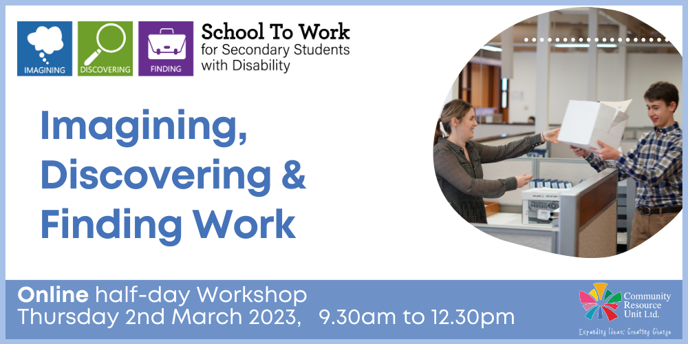

Imagining, Discovering and Finding Work
Community Resource Unit Ltd

Online ½ Day workshop: Thursday 2nd March 2023 from 9:30AM to 12.30PM

Presenter:
Gina Barwell

Cost: There is no cost to attend but registration is essential

About the Workshop:
- Join us for an interactive half-day online workshop with a small number of families.
- This workshop will enable participants to get started in a range of processes so they leave with some concrete plans and strategies to find work for their family member.
- Participants will hear stories and gain practical tips from experiences from people with a disability and their family members.

This workshop covers:
- Uncovering and identifying individual strengths and interests and using them as a guide for creating potential work roles
- Identifying the conditions that help set up your family member for success in work
- Identifying community connections and contacts to approach for work
- Developing a positive pitch to get the job
- Exploring what good employment support looks like and how to find the right people to support your family member

Who Should Attend:
- This online workshop is for secondary school students with disabilities and their families. Supporters and allies are also welcome to attend.

What do I need to participate?
We will be using the video meeting platform Zoom to host the webinar.
You will need access to:
- a computer or iPad/tablet or smart phone with internet access;
- speakers/sound

This interactive workshop will be of interest to anyone who is thinking about future work for their family member with disability who is in secondary school – whether as a parent, family member, friend, ally or in a work role.
Please contact us if you have any questions or concerns about your ability to participate.
Please note: This workshop will not be recorded.

Event Details

Date and Time
- Thursday 4th August 2022
- The link to join the webinar will be sent to your registered email address closer to the event. The Consultants will open the webinar in time for people to join and get settled before the start time.
- The ½ day online workshop runs from 9:30AM to 12.30PM

Venue Details
- The webinar will take place online and the link to join will be emailed prior to the event.

Cost
- There is no cost to attend, but registration is essential.
- The project is being provided as part of the Community Inclusion Capacity Development program through The Department of Social Services.

Tickets
- Please register and book your tickets through the following link: https://events.humanitix.com/online-workshop-imagine-discover-find-aug22

RSVP
- Registrations close on Thursday 28th July 2022 (11.55PM)

Cancellations
- CRU's cancellation policy is on our website. Please use the following link: http://cru.org.au/about/policies/#cancellation

About Community Resource Unit Ltd.
- CRU has a 30 year track record of working across Queensland to help people with a disability take control of their lives and take their place in their community.
- CRU (QLD), Resourcing Inclusive Communities, an initiative of Family Advocacy (NSW) and Imagine More (ACT) are working together on a project called ‘School to Work’. 'School to Work’ aims to increase the confidence of and motivate students with disability with the support of their families to seek out meaningful, paid employment in the community.
- The project is being provided as part of the Community Inclusion Capacity Development program through The Department of Social Services.

Contact Community Resource Unit Ltd.

Phone
07 3844 2211

Email
cru@cru.org.au

Website
www.cru.org.au

Address
Level 2, 43 Peel Street, South Brisbane, Queensland, 4101.

ABN/ACN
ABN:16 143 460 250 ACN: 617 860 009

