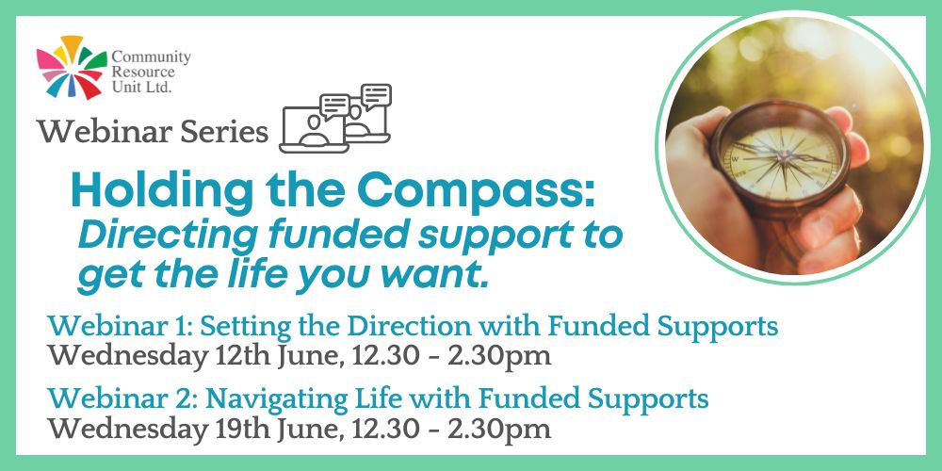

Webinar Series: Holding the Compass: Directing Funded Support to Get the Life You Want
Community Resource Unit Ltd

Two-part webinar series: Wednesday 12th June and Wednesday 19th June.

Cost
$35 per webinar for people with disability and family members. $75 per webinar for workers, friends and allies.

About the Webinars
Does having paid support really make your life better? Are there things you would like to change?
Paid support has an important role in the lives of people with disability. When this paid or ‘formal’ support is not done well or used well, it can become something that gets in the way of friendships, relationships and ordinary life.
In this replay of a two-part webinar series find out in webinar 1 how you can set the direction for success with your paid supports and in webinar 2 how you can develop the skills and confidence to get the most out of paid supports.
Register for one or both webinars.
Webinar 1: Setting the direction with funded supports
It is essential to know what you want and need from paid support if that support is going to work well for you. This webinar helps by looking at:
- What is good formal support?
- Making sure you are setting the direction.
- The importance of goals and vision.
- Getting the quality support you want.

Webinar 2: Navigating life with funded supports
Navigating life with funded supports is about staying on track, and moving forwards towards the life you choose. This webinar helps by looking at:
- Respectful and productive relationships with people in paid support roles
- Taking a lead, so paid supports are working towards your vision and goals
- Reviewing your formal supports and checking for resilience
Whilst we encourage you to join us live, these webinars will be recorded and will be available to watch for 14 days after the event.

Who Should Attend
This webinar series is relevant to people with disability and family members who have paid supports, services or organisations in their life, regardless of how their funding is managed. Workers, friends and allies are also very welcome.

Event Details

Date and Time
- Wednesday 12th June AND Wednesday 19th June
- 12.30pm to 2.30pm

Location
- Online

Cost
- $35 per webinar for people with disability and family members
- $75 per webinar for workers, friends and allies.
- This event is partly subsidised by the Commonwealth Department of Social Services grant. If cost is a barrier to attending, please contact CRU to discuss.

Tickets
Please register and book your tickets through the following link:
https://events.humanitix.com/tours/holding-the-compass-webinars-replay-tour-2024

RSVP
- Registrations close on Monday 3rd June for Webinar 1
- Registrations close on Thursday 13th June for Webinar 2

Cancellations
- CRU's cancellation policy is on our website. Please use the following link: http://cru.org.au/about/policies/#cancellation

About Community Resource Unit Ltd.
- CRU has a 30 year track record of working across Queensland to help people with a disability take control of their lives and take their place in their community.

Contact Community Resource Unit Ltd.

Phone
07 3844 2211

Email
cru@cru.org.au

Website
www.cru.org.au

Address
Level 2, 43 Peel Street. South Brisbane. Queensland.

ABN/ACN
ABN:16 143 460 250 ACN: 617 860 009

