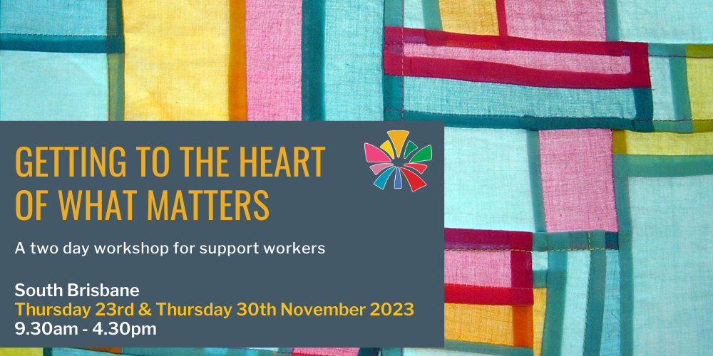

Event Name: Getting to the Heart of What Matters – a 2 day workshop for Support Workers
Presented by Community Resource Unit Ltd

Where: South Brisbane

Date: Thursday 23rd and Thursday 30th November 2023

Presenter: Bronwyn Moloney

Cost: $300 for 2 days

Course Outline
- Paid staff can make a significant contribution to the life of a person with disability – enabling the person to live a rich life and pursue their unique goals and dreams. What lies at the heart of the role is, however, frequently invisible. When we fall into the habit of talking about ‘hours’, tasks, routines and schedules, it’s easy to be distracted from what really matters about supporting people well.
- This two-day workshop is highly interactive and offers many practical strategies to assist you in your role. Day 1 offers an opportunity for support workers to critically reflect on the purpose of their role and the values that drive support. Day 2 extends on foundational topics and delves into some of the complexities of support work...

Who is this workshop for?
- This training is for support workers who are directly assisting a person with disability to live a good life in community.
- If you or your organisation wants to register more than four workers, please contact CRU to discuss this.

Topics covered
Day 1 offers an introduction to effective support work that focuses on the following topics:
- The purpose of support work
- Getting to know the person
- Valued roles
- Promoting friendships & relationships
- Connecting people to community Barriers to good support
Day 2 delves into some of the complexities of support work, particularly in relation to:
- Effective working relationships with people with disability & families
- Extending relationship & community building
- Identifying places of welcome
- Developing skills & competencies
- Supporting people to make choices
“…working together in partnership, with the right people…creates fertile ground for establishing a good life…”

About the Presenters
- Our experienced disability consultants and presenters bring a wealth of experience in supporting people with disability and families in their efforts towards a good and ordinary life.
- The content of our workshops is brought to life through the sharing of examples and personal stories that illustrate how the ideas can be implemented.

Additional Information
- Enquiries: For more information, please call us or visit the "Fee for Service" page on the CRU website
- Learning Objectives: Please refer back to our website for Learning Objectives for this workshop. They should assist NDIS participants and their supporters to determine if they relate to the participant’s goals.
- Fees & Cancellation: If price is a barrier then please contact us to discuss your options further. To see our cancellation policy please visit our website.
- Assistance: Please contact CRU if you require assistance to register, attend or participate in this event by calling (07) 3844 2211 or email us at cru@cru.org.au

Using Your NDIS Funding at CRU
For self-managing and plan-managed NDIS participants, see the Learning Objectives on the event's page. You can decide if this is a reasonable and necessary support to help you (or your family member) achieve their goals.

Event and Venue Details

Date and Time
- Thursday 23rd and Thursday 30th November 2023
- The workshop runs from 9:30am to 4.30pm.
- Please arrive to sign-in from 9.00am for a 9.30am start.

Venue details
- Venue is Community Resource Unit Ltd Training Room
- Level 2/43 Peel Street, South Brisbane, QLD 4101
- See the Finding our Office on the CRU website for information on how to get here and parking.

Cost
- $300 per person
- NB: This workshop was redesigned at the end of 2020 from a one-day course to two days.
- Light lunch and refreshments will be provided.

Purchase Tickets
- Please register and book your tickets through the following link:
https://events.humanitix.com/getting-to-the-heart-nov23

RSVP
- Registrations close on Wed 15th November 2023

Cancellations
- CRU's cancellation policy is on our website.
- Please use the following link: http://cru.org.au/about/policies/#cancellation

About Community Resource Unit Ltd.
- CRU has a 30 year track record of working across Queensland to help people with a disability take control of their lives and take their place in their community.

Contact Community Resource Unit Ltd.

Phone
07 3844 2211

Email
cru@cru.org.au

Website
www.cru.org.au

Address
Level 2, 43 Peel Street. South Brisbane. Queensland.

ABN/ACN
ABN:16 143 460 250 ACN: 617 860 009

