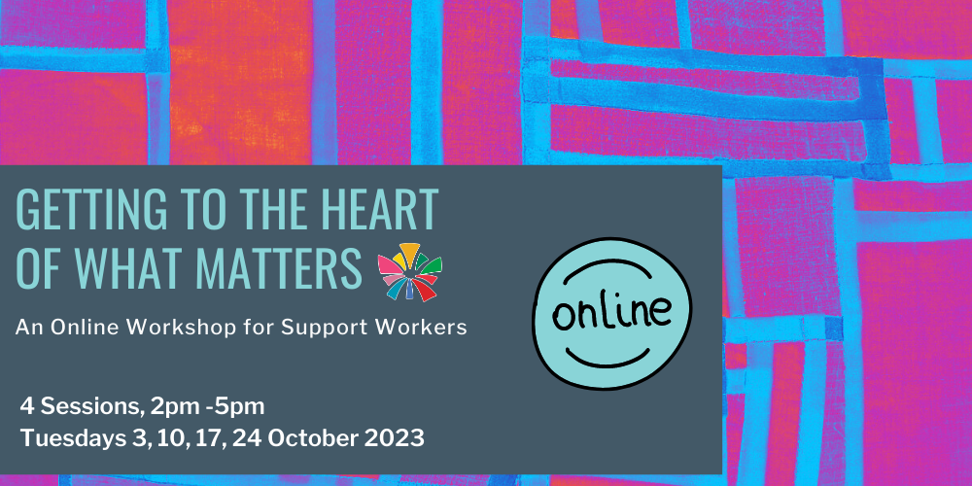

Event Name: Getting to the Heart of What Matters – An Online Workshop for Support Workers
Presented by Community Resource Unit Ltd

Where: Online – using the Zoom online platform

Date: 4 Tuesdays – 3rd, 10th, 17th and 24th October

Cost: $300 for all sessions.
Participants must attend all four sessions and complete brief tasks prior to/ between each session. This is a live online event which will not be recorded.

Course Outline
- Paid staff can make a significant contribution to the life of a person with disability – enabling the person to live a rich life and pursue their unique goals and dreams. What lies at the heart of the role is, however, frequently invisible. When we fall into the habit of talking about ‘hours’, tasks, routines, and schedules, it’s easy to be distracted from what really matters about supporting people well.
- This four-session, interactive workshop focuses on the values that underpin and drive support, with an emphasis on valued roles and community belonging. The workshop will also delve into some of the complexities of support work, including working collaboratively and developmentally, and supporting decision-making.

Who is this workshop for?
This training is for support workers who are directly assisting a person with disability to live a good life in community.

The online workshop is participatory with lots of opportunities to engage in activities – participants are expected to use their microphone and keep their video on.

If you or your organisation wants to register more than four workers, please contact CRU to discuss this.
Please contact CRU if you requre assistanec to register, attend or participate in this event
Participants must attend all four sessions and complete brief tasks prior to/ between each session. This is a participatory and live online workshop, and as such which will not be recorded.

What do I need for the workshop?
This is an interactive workshop! You will be asked questions and share your ideas with other people.
You will need:
- a computer or tablet device
- internet access
- speakers or headphone and a microphone
- Somewhere a bit quiet where you can concentrate
We do not recommend you join this workshop on a phone.

Unsure about attending online?
CRU’s online workshops are engaging, interactive and welcoming:
- “Very successful presentation online with good use of technology to make people feel connected”
- For “people not in Brisbane this format gives them an opportunity they may not otherwise been able to participate. Well presented. Job well done.”
- “Effective delivery, clear concise and engaging. Being clear up front about how to work the technology and explaining expectations of participants was spot on and contributed to a productive session. Thank you.”

Topics covered
- The purpose of support work
- Values, beliefs and assumptions
- Getting to know the person
- Valued roles
- Promoting friendships & relationships
- Identifying places of welcome
- Connecting people to community
- Supporting people to make choices
- Developing skills & competencies
- Extending relationship & community building
“[Support] requires a certain humility on the part of staff, letting go of control, a willingness to follow rather than lead.” Susan Stanfield

About the Presenters
- Our experienced disability consultants and presenters bring a wealth of experience in supporting people with disability and families in their efforts towards a good and ordinary life.
- The content of our workshops is brought to life through the sharing of examples and personal stories that illustrate how the ideas can be implemented.

Additional Information
- Enquiries: For more information, please call us or visit the "Fee for Service" page on the CRU website
- Learning Objectives: Please refer back to our website for Learning Objectives for this workshop. They should assist NDIS participants and their supporters to determine if they relate to the participant’s goals.
- Fees & Cancellation: If price is a barrier then please contact us to discuss your options further. To see our cancellation policy please visit our website.
- Assistance: Please contact CRU if you require assistance to register, attend or participate in this event by calling (07) 3844 2211 or email us at cru@cru.org.au

Using Your NDIS Funding at CRU
For self-managing and plan-managed NDIS participants, see the Learning Objectives on the event's page. You can decide if this is a reasonable and necessary support to help you (or your family member) achieve their goals.

Event and Venue Details

Date and Time
- 4 Tuesdays: 3, 10, 17 and 24 October 2023
- The online workshop runs from 2.00PM to 5.00PM.
- Please join in from 1.45pm to ensure your connection is working.

Venue details
- This event will be held online, using the Zoom online platform.

Cost
- $300 per person

Purchase Tickets
- Please register and book your tickets through the following link:
- https://events.humanitix.com/getting-to-the-heart-online-oct23

RSVP
- Registrations close on Sunday 24th September 2023

Cancellations
- CRU's cancellation policy is on our website.
- Please use the following link: http://cru.org.au/about/policies/#cancellation

About Community Resource Unit Ltd.
- CRU has a 30 year track record of working across Queensland to help people with a disability take control of their lives and take their place in their community.

Contact Community Resource Unit Ltd.

Phone
07 3844 2211

Email
cru@cru.org.au

Website
www.cru.org.au

Address
Level 2, 43 Peel Street. South Brisbane. Queensland.

ABN/ACN
ABN:16 143 460 250 ACN: 617 860 009

