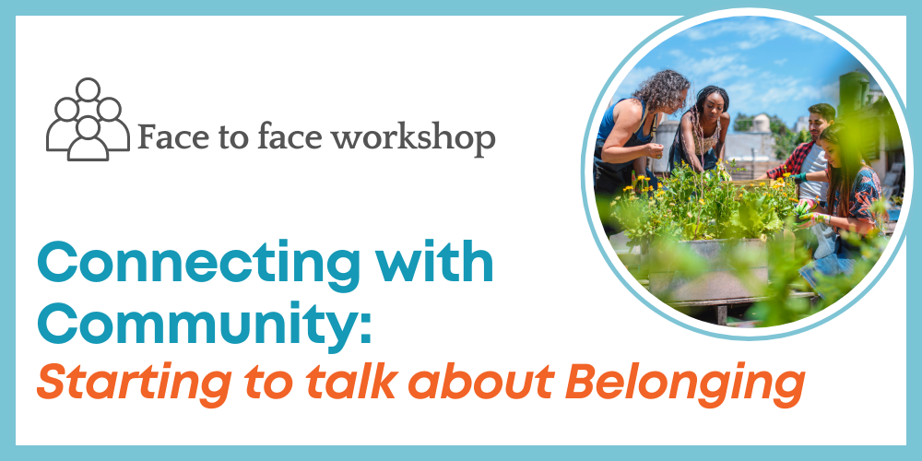

# Connecting with Community – Starting to Talk About Belonging

Community Resource Unit Ltd

## Sunnybank Workshop – Wednesday 31st May 2023, 9.30 AM to 4.30 PM

## Presenters

CRU Consultants

## Cost

$50 per ticket for People with Disability and Family members, $150 ticket for Workers, Friends and Allies

## About the Workshop

* There are a lot of reasons why people with disability may not be as connected with community as they would like to be. Yet the need to belong is fundamental to all of us. We all want to feel like our presence is noticed and valued by others.
* Like most good things in life, building belonging takes work. But experience tells us that there are real things we can do to make connections and to build belonging and that the effort and is well worth it.
* This practical workshop explores what it means to belong, and looks at the challenges and barriers to belonging that people with disability can experience.
* It covers strategies and tips to discover what may already be at your fingertips as we map our community to look for opportunities for connection. You will brainstorm new ways to make a contribution, and become strategic in how you seek out membership of new groups and make your approach to be part of something new.
* This workshop provides ideas and tools that can inspire you to work towards real and meaningful inclusion in your community, be that in your neighbourhood, at work, at school or your local social and sporting clubs. There will be time for workshop participants to discuss, brainstorm and share together in order to explore how and where to begin.

## Who Should Attend

* This workshop is for people with disability, their families, friends and supporters. It will be of interest to anyone who wants to achieve real belonging and inclusion for themselves or for someone they care about.
* It can be beneficial for people to attend with support workers, or other people who might help to implement these steps.

**Recent attendees at this workshop have said:**

“This workshop introduced topics such as what inclusion is and why it's important, and how to achieve inclusion… You get a lovely introduction to these concepts, with resources to look into it further. I especially liked the practical tools like the Power of 10 in identifying opportunities for connection in community and how to be involved in community in a meaningful way. “

“I took away SO MANY practical strategies and frameworks to facilitate my son's connection in the community.”

# Event Details

## Date and Time

* Wednesday 31st May 2023
* The workshop runs from 9.30AM – 4.30PM, but please arrive from 9AM to sign-in.

## Venue

* Sunnybank Community & Sports Club
* 470 McCullough St, Sunnybank

## Cost

* $50 per ticket for people with a disability and family members
* $150 per ticket for workers, friends and allies

*The cost of this event is partially subsidised by a Department of Social Services grant.

If cost is a barrier to attending, please contact CRU to discuss.

For self-managing and plan-managed NDIS participants, see the Learning Objectives below. You can decide if this is a reasonable and necessary support to help you (or your family member) achieve their goals.

## Learning Objectives

* To explore the importance of belonging and contribution for all people
* To analyse why belonging doesn’t just happen for people with disability
* To understand what it takes for all people to belong
* To challenge some of the assumptions and beliefs that people can hold for people with disability
* To develop ideas and strategies to more intentionally assist people to belong in the communities of their choice

## Tickets

* Please register and book your tickets through the following link:
* <https://events.humanitix.com/sunnybank-connecting-with-community-may23>

## RSVP

* Registrations close on Sunday 21st May 2023

## Cancellations

* CRU's cancellation policy is on our website. Please use the following link: <http://cru.org.au/about/policies/#cancellation>

## About Community Resource Unit Ltd.

* CRU has a 30-year track record of working across Queensland to help people with a disability take control of their lives and take their place in their community.

# Contact Community Resource Unit Ltd.

## Phone

07 3844 2211

## Email

[cru@cru.org.au](mailto:cru@cru.org.au)

## Website

[www.cru.org.au](http://www.cru.org.au)

## Address

Level 2, 43 Peel Street. South Brisbane. Queensland.

## ABN/ACN

ABN:16 143 460 250 ACN: 617 860 009

COVID 19: Please do not attend on the day if you are feeling unwell, have COVID-like symptoms or have been a close contact with a confirmed case.