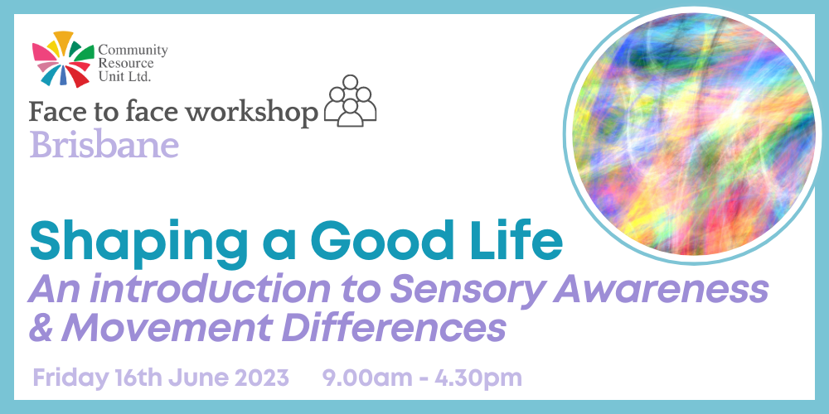

Shaping a Good Life: An Introduction to Sensory Awareness & Movement Disorders
Community Resource Unit Ltd

Friday 16th June 2023 from 9.00AM to 4.30PM (please arrive from 8.30AM to sign-in for a 9AM start)

Presenters:
Joyce-Lyn Smith

Cost:
$50 per ticket for People with Disability and Family members, $150 ticket for Workers, Friends and Allies

About the Workshop
- Before we can thrive at school or work, or in friendships and relationships, we all need to have our fundamental needs met. Some of our needs can be entirely unique to us, but if we can’t express or understand those needs it can impact everything else in our life.
- Sensory and movement differences can help to explain previously misunderstood needs. This highly interactive workshop is full of real life examples and scenarios, and it will leave you with practical accommodations, strategies and ideas you can apply for yourself, a family member or a person you support.

This workshop covers
- Foundational knowledge in Sensory & Movement differences
- The functions and physiology of the senses
- Sensory Integration Dysfunction, and related disorders
- Common difficulties/observations for people with hypo/hyper arousal of each sense.
- Practical sensory experiences; understanding own preferences.
- Sensory relations to anxiety/behaviour & management ideas
- Practical applications, tools, and examples.
The topic will be relevant for many people, including people with a diagnosis of Autism and other neurological difference.
Places are strictly limited.

About the Presenter
Joyce-Lyn Smith has 25 years of professional experience supporting people with complex support needs in a variety of environments and settings. Living in Townsville, she is the Clinical Director at PoDDSS (Professional Disability Development Supports & Services) and has previously worked in the Intensive Behaviour Support Team with the Queensland government.
Following completion of the mentoring program with Professor Anne M. Donnellan, University of San Diego and Martha R. Leary (SLP), Nova Scotia in 2009, Joyce-Lyn collaborated with Learning Disability & Mental Health Nurse Karl Jacks to develop this workshop

Who Should Attend
This event is for people with disability, their families and supporters. It will be of interest to supporters of people who experience sensory difference or movement difference, and is particularly beneficial if attended as a team.

Event Details

Date and Time
- Friday 16th June 2023
- The workshop runs from 9:00AM to 4.30PM, but please arrive from 8.30am to sign-in

Venue details
- The Jindalee Hotel, Sinnamon Road, Jindalee QLD 4074
- Windermere Room
- There is parking on-site, ramp access facing the First Choice Liquor.

Cost
- $50 per ticket for people with a disability and family members
- $150 per ticket for workers, friends, and allies
- The cost to attend includes lunch and light refreshments throughout the day
- This event is partly subsidised by the Commonwealth Department of Social Services through an Information, Linkages and Capacity Building (ILC) grant. If cost is a barrier to attending, please contact CRU to discuss.

For self-managing and plan-managed NDIS participants, see the Learning Objectives on the event's page. You can decide if this is a reasonable and necessary support to help you (or your family member) achieve their goals.

Tickets
- Please register and book your tickets through the following link:
- https://events.humanitix.com/brisbane-shaping-a-good-life-jun23

RSVP
- Registrations close on Monday 5th June 2023

Cancellations
- CRU's cancellation policy is on our website. Please use the following link: http://cru.org.au/about/policies/#cancellation

About Community Resource Unit Ltd.
- CRU has a 30 year track record of working across Queensland to help people with a disability take control of their lives and take their place in their community.

Contact Community Resource Unit Ltd.

Phone
07 3844 2211

Email
cru@cru.org.au

Website
www.cru.org.au

Address
Level 2, 43 Peel Street. South Brisbane. Queensland.

ABN/ACN
ABN:16 143 460 250 ACN: 617 860 009

