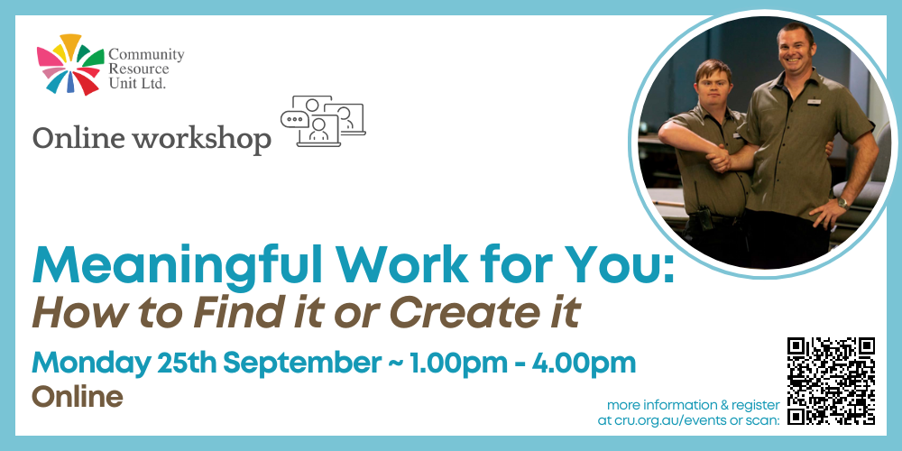

Meaningful Work For You: How to Find it or Create it!
Community Resource Unit Ltd

Online workshop: Monday 25th September 2023 from 1.00PM to 4.00PM

Cost:
$35 per ticket for People with Disability and Family members, $75 ticket for Workers, Friends and Allies

About the Workshop
- This interactive online workshop is for people with disability who want to work but know the traditional pathways won’t lead to the jobs and career they want.
- It can help get you started in working out what sort of job would be right for you or your family member, and learn about different way to get it, even if it means creating a job yourself.
- Come on your own or with the people who will help you work towards a goal of a meaningful job

At this workshop you will:
- Learn how to come up with job ideas based on what you are good at and interested in.
- Work out the things that will set you up to do well in a job.
- Hear about different and creative ways to get or create meaningful jobs.
- Bring it all together to figure out your next steps.
- Start to develop innovative ways to tell workplaces about yourself.
- Learn about things that will help you keep meaningful work once you have it.

Who Should Attend
- This workshop will be particularly useful for people with developmental disabilities, their families, friends and workers. Whether you have just started thinking about work, or are interested in trying or doing something different, this workshop is for you.

What do I need for this workshop?
- This is an interactive workshop! You will be asked questions and share ideas with other people.

- You will need:
  - a computer or tablet device
  - internet access
  - speakers or headphone and a microphone
  - Somewhere a bit quiet where you can concentrate

- We do not recommend you join this workshop on a phone.

Event Details

Date and Time
- Monday 25th September 2023
- The online workshop runs from 1.00PM to 4.00PM

Venue details
- The webinar will take place online and the link to join will be emailed prior to the event.

Cost
- $35 per ticket for people with a disability and family members
- $75 per ticket for workers, friends, and allies
- This event is partly subsidised by the Commonwealth Department of Social Services grant. If cost is a barrier to attending, please contact CRU to discuss.

For self-managing and plan-managed NDIS participants, see the Learning Objectives on the event's page. You can decide if this is a reasonable and necessary support to help you (or your family member) achieve their goals.

Tickets
Please register and book your tickets through the following link:
https://events.humanitix.com/online-meaningful-work-for-you-sept23

RSVP
- Registrations close on 12th September 2023

Cancellations
- CRU's cancellation policy is on our website. Please use the following link: http://cru.org.au/about/policies/#cancellation

About Community Resource Unit Ltd.
- CRU has a 30 year track record of working across Queensland to help people with a disability take control of their lives and take their place in their community.

Contact Community Resource Unit Ltd.

Phone
07 3844 2211

Email
cru@cru.org.au

Website
www.cru.org.au

Address
Level 2, 43 Peel Street. South Brisbane. Queensland.

ABN/ACN
ABN:16 143 460 250 ACN: 617 860 009

