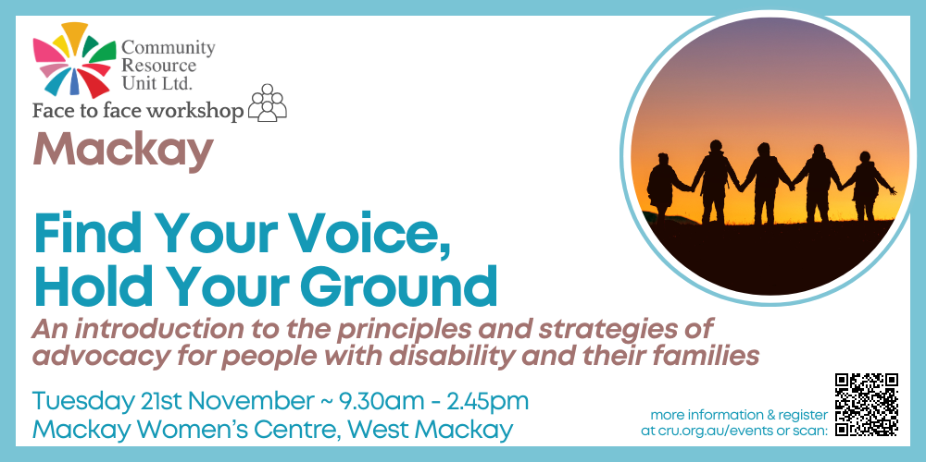

# Find Your Voice, Hold Your Ground : An introduction to the principles and strategies of advocacy for people with disability and their families

Presented by: Community Resource Unit Ltd

## Mackay Workshop – Tuesday 21st November 2023, 9.30 AM to 2.45 PM

## Presenters

Jenny Smith and Catherine Laherty

## Cost

$50 This event is for **people with disability and family members**, or close friends or allies who take up an **unpaid** advocacy role for an individual. It is not suitable for workers.

## About the Workshop

* Unfortunately people with disability are not offered the same opportunities as others in our community and they regularly need to speak up, or have people to speak up for them to get a fair go. Often, families must become advocates because their family member faces rejection, discrimination or low expectations.
* This workshop will help people with disability and family members to “find their voice”, stand their ground, and become more effective in influencing what happens in their life, or for their family member.
* This workshop provides ideas and tools that can inspire you to work towards real and meaningful inclusion in your community, be that in your neighbourhood, at work, at school or your local social and sporting clubs. There will be time for workshop participants to discuss, brainstorm and share together in order to explore how and where to begin.
* This workshop, led by presenters with experience in advocating for and alongside people with disability, will introduce participants to the principles and fundamentals of social advocacy.
* Topics covered will include advocacy strategies, pitfalls, how to deal with feelings of emotional vulnerability, and how to stay focussed on your best interests, or those of your family member.

## About the Presenters

* Jenny Smith was a founding member of Capricorn Citizen Advocacy in Rockhampton and is herself a Citizen Advocate. Jenny is Capricorn Citizen Advocacy’s delegate to the Queensland Independent Disability Advocacy Network. She is a former Director of Disability Advocacy Network Australia, and a former Deputy Chairperson of the Queensland Disability Advisory Council. She has recently worked for Queensland Advocacy for Inclusion as a Decision Support Advocate and an NDIS Appeals Advocate.
* Catherine Laherty has worked at CRU for 8 years, where she is a Senior Consultant. As one of Catherine’s older brothers has a disability, she has a life-long interest in and commitment to the rights of people with disability. She has a personal and professional interest in collective advocacy and efforts for change. Before coming to CRU Catherine worked at Amnesty International Australia and in the trade union movement on state and national campaigns for equal pay.

## Who Should Attend

This workshop is for **people with disability and family members**, as well as close friends and allies, who take up an **unpaid** advocacy role, or would like to learn where to begin. It is not suitable for workers.

This workshop covers similar material to *The Meaning of Advocacy* workshop previously offered by CRU.

# Event Details

## Date and Time

* Tuesday 21st November 2023
* The workshop runs from 9.30AM – 2.45PM, but please arrive from 9AM to sign-in.

## Venue

* Mackay Women’s Centre, Alcorn Room
* 418 Shakespeare Street, West Mackay, QLD

## Cost

* $50* per ticket for **people with a disability and family members**

*The cost of this event is partially subsidised by a Department of Social Services grant.

If cost is a barrier to attending, please contact CRU to discuss.

For self-managing and plan-managed NDIS participants, see the Learning Objectives below. You can decide if this is a reasonable and necessary support to help you (or your family member) achieve their goals.

## Learning Objectives

By the end of this workshop you will:

* Understand why people with disability need social advocacy.
* Recognise what to advocate for: inclusion and ‘the good life’ for people with disability.
* Know what common forms of social advocacy there are and what they mean, and understand what may be called advocacy that is not.
* Be able to describe the elements or principles of social advocacy and their importance.
* Look at the costs of advocacy and consider where potential conflicts of interest lie.
* Identify barriers to social advocacy and how to overcome them.
* Develop strategies to support effective advocacy.

## Tickets

* Please register and book your tickets through the following link:
* [https://events.humanitix.com/find-your-voice-mackay-nov23](https://events.humanitix.com/gold-coast-connecting-with-community)

## RSVP

* Registrations close on Thursday 9th November 2023

## Cancellations

* CRU's cancellation policy is on our website. Please use the following link: <http://cru.org.au/about/policies/#cancellation>

## About Community Resource Unit Ltd.

* CRU has a 30-year track record of working across Queensland to help people with a disability take control of their lives and take their place in their community.

# Contact Community Resource Unit Ltd.

## Phone

07 3844 2211

## Email

[cru@cru.org.au](mailto:cru@cru.org.au)

## Website

[www.cru.org.au](http://www.cru.org.au)

## Address

Level 2, 43 Peel Street. South Brisbane. Queensland.

## ABN/ACN

ABN:16 143 460 250 ACN: 617 860 009

COVID 19: Please do not attend on the day if you are feeling unwell, have COVID-like symptoms or have been a close contact with a confirmed case.