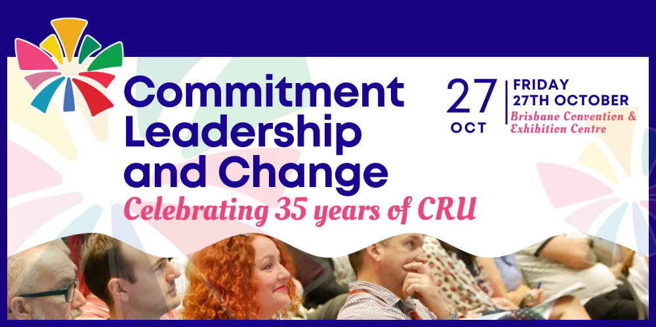

Live Event: Commitment, Leadership and Change: Celebrating 35 years of CRU
Presented by Community Resource Unit Ltd

South Brisbane: Friday 27th October 2023

Ticket Information:
- Full day Forum only: $75, 9.30AM – 5PM. These tickets do not include the Community Catch-Up after the forum.
- Celebratory Community Catch-Up: $45. 5.30PM - 7.30PM. This ticket is for the Community Catch-Up only.
- Forum and Community Catch-Up: $100. 9.30AM - 5.00PM and then 5.30PM - 7.30PM. This ticket is for the all-day forum and to join us for the Community Catch-Up afterwards.

About the Event:
- What does grassroots change for people with disability actually take?
- In celebration of 35 years of CRU, this full day forum will showcase leaders among us. Hear stories from individuals and families who imagined better, spoke up, got started and kept going, and brought people with them.
- Be inspired by the efforts of others, and take the opportunity to reflect on how you are contributing to positive change. After all, if not us, then who?
- And at the end of this inspiring day, join us for a Celebratory Community Catch-Up, with canapés!

About the Presentations

- Never Too Late to Get a Life, by Cathy McMahon and Josey McMahon
- This is the story of twin sisters Josey and Cathy, whose lives diverged at the age of 11. Their very different paths eventually joined again, many decades later. Hear how Josey rethought what was possible for Cathy and helped her reconnect with the family and wider world once again. At its heart this story is about personal change, reconnection and the power of family and relationships.

- You Can Get There from Here, But What Did It Take? By Valen Litster and Sally Aubrey
- This presentation is a loving evocation of the Litster family, which attempts to give hope to younger families in the trenches. Coming out of times of early chaos, the members of the family have each found their feet and emerged into good lives. The story is a salutary tale of what can happen when a family consciously agrees to work together for the good of the whole.

- Co-operation Will Lead Us into the Future, by Nazim Ahmed
- Through stories of his life, Nazim will reflect on cooperation and leadership, drawing on his experience of acquiring a disability and as an active leader in the Sudanese community in Australia. His presentation will highlight how strategies for change are similar across different groups and cultures – the sustaining power of Vision, recognising the impact of others and the power of working together, and preparing for succession by investing in future generations.

- I’m Speaking Up for People with Intellectual Disability. If I Don’t, Who Will? By Donna Best and Kathy Ellem
- The University of Queensland asked Kathy Ellem to do a TEDx talk about stories of people with intellectual disability. Kathy said she wouldn’t do it without a person with intellectual disability. Donna Best, a self-advocate agreed to speak with Kathy. Kathy and Donna had to change some of the TED rules to make their talk happen. They share what they did, and share their TEDx talk as well.

About the Presenters
- Cathy McMahon’s childhood was spent in rural Queensland as part of a large family, until at age 11 she moved to live in a large institution where she remained for 47 years. Nine years ago she embraced the opportunity to move and Cathy now lives a completely different life, in a home on the Gold Coast just around the corner from her sister Josey. Making up for lost time, Cathy is an artist and an active and valued member of her local community, including her local church.

- Josey McMahon’s own experience of living with a disability and having a sister with disability has given her a passion for the rights of all those who are disadvantaged. Through her life she has had the opportunity to be a wife, mother, step-mother, and grandparent. Josey is also a social worker,was the Manager of Gold Coast Advocacy (GCA) and the manager of the Community Enablers project. Josey now works as an independent consultant helping people to build great lives through planning.

- Valen Litster is a Townsville man who lives with disability. He is a small business owner helping to keep the good people of Townsville caffeinated. In his spare time, he enjoys woodworking and socialising regularly with his friends and extended family. Valen has lived in his own home for nearly 20 years and with support, he manages his own household. Valen is a man of strong opinions and his team values and acts on his choices. Life is good!

- Sally Aubrey is a mother of two and sister to Valen and their sister Jane, who also lives with a disability. She lives in Townsville and is a Specialist in Obstetrics and Gynaecology. Sally and her husband Tom are aware of the need to maintain a presence in her siblings’ lives without being the primary support. Sally feels that her work has been heavily influenced by growing up in a chaotic but strong family where each child’s value and strengths were celebrated.

- Nazim Ahmed was born and raised in Sudan. He studied and worked in the medical field, earning a Doctor of Medicine in Sudan and a Fellowship in Glaucoma in Finland. In 2018, just before moving to Australia, Nazim lost his sight which changed the course of his life. He is currently pursuing a Master of Public Health. Nazim serves as the Chairperson of the Darfur Community in Queensland and is a respected leader in the Sudanese community in Australia. In his spare time, he enjoys music and reading and writing non-fiction.

- Donna Best is a leader in self-advocacy. She is the peer leader of Hot Topics, a self advocacy group for people with intellectual disabilities in Queensland, based at Queenslanders with Disability Network. She is a founding member of many disability advocacy groups in Queensland. Donna regularly provides advice to a range of government and community service organisations. Known for her phenomenal memory, she provides her experience and knowledge to key committees, groups and boards, and is currently on the Queensland Advocacy for Inclusion board.

- Dr Kathy Ellem is a Senior Lecturer in the School of Nursing, Midwifery and Social Work at The University of Queensland. She has previously practiced as a social worker in both government and non-government sectors. One of Kathy’s best teachers is her son Aidan, a young man with intellectual disability. Kathy is a former president of Qld Parents for People with Disability (QPPD), which is where Kathy and Donna first met. They have known each other and collaborated for over 25 years.

Who Should Attend
- This event is for people with disability, their families, friends and allies, workers and professionals and community members who are interested in meaningful change so people with disability can take their place in community.

Event Details

Date and Time
- Friday 27th October 2023
- The daytime forum runs from 9.30AM to 5PM (please arrive from 9AM to sign-in)
- The Celebratory Community Catch-up afterwards runs from 5.30PM – 7.30PM

Venue details
- Brisbane Convention and Exhibition Centre, Rooms B1 & B2, South Brisbane, QLD.
- Enter via Grey Street with ramp and then Lift (opposite Oleo Café) or escalator access to Boulevard Level.

Cost
- Full day Forum only: $75, 9.30AM – 5PM. These tickets do not include the Community Catch-Up after the forum.
- Celebratory Community Catch-Up: $45. 5.30PM - 7.30PM. This ticket is for the Community Catch-Up only.
- Forum and Community Catch-Up: $100. 9.30AM - 5.00PM and then 5.30PM - 7.30PM. This ticket is for the all-day forum and to join us for the Community Catch-Up afterwards.

Tickets
Please register and book your tickets through the following link: https://events.humanitix.com/celebrating-35-years

RSVP
- Registrations must close on 12th October 2023

Cancellations
- CRU's cancellation policy is on our website. Please use the following link: http://cru.org.au/about/policies/#cancellation

About Community Resource Unit Ltd.
- CRU has a 30 year track record of working across Queensland to help people with a disability take control of their lives and take their place in their community.

Contact Community Resource Unit Ltd.

Phone
07 3844 2211

Email
cru@cru.org.au

Website
www.cru.org.au

Address
Level 2, 43 Peel Street. South Brisbane. Queensland.

ABN/ACN
ABN:16 143 460 250 ACN: 617 860 009

