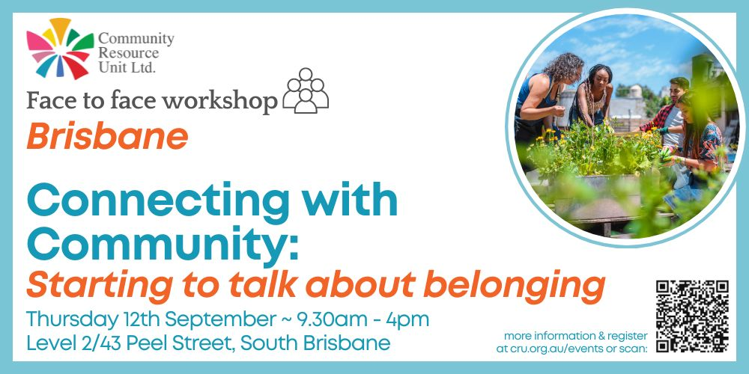

Connecting with Community – Starting to Talk About Belonging
Community Resource Unit Ltd

Brisbane Workshop – Thursday 12th September 2024, 9.30AM to 4PM (please arrive from 9AM to sign-in)

About the Workshop
- There are a lot of reasons why people with disability may not be as connected with community as they would like to be. Yet the need to belong is fundamental to all of us. We all want to feel like our presence is noticed and valued by others.
- Like most good things in life, building belonging takes work. But experience tells us that there are real things we can do to make connections and to build belonging and that the effort and is well worth it.
- This practical workshop explores what it means to belong, and looks at the challenges and barriers to belonging that people with disability can experience.
- It covers strategies and tips to discover what may already be at your fingertips as we map our community to look for opportunities for connection. You will brainstorm new ways to make a contribution, and become strategic in how you seek out membership of new groups and make your approach to be part of something new.

Who Should Attend
- This workshop is for people with disability, their families, friends and supporters. It will be of interest to anyone who wants to achieve real belonging and inclusion for themselves or for someone they care about.
- It can be beneficial for people to attend with support workers, or other people who might help to implement these steps.
Recent participants of this workshop have said:
“This workshop introduced topics such as what inclusion is and why it's important, and how to achieve inclusion… You get a lovely introduction to these concepts, with resources to look into it further. I especially liked the practical tools like the Power of 10 in identifying opportunities for connection in community and how to be involved in community in a meaningful way.”
“I took away SO MANY practical strategies and frameworks to facilitate my son's connection in the community.”

Event Details

Date and Time
- Thursday 12th September 2024
- The workshop runs from 9.30AM – 4PM, but please arrive from 9AM to sign-in.

Venue
- CRU Office, Level 2 43 Peel Street, SOUTH BRISBANE 4101

Cost
- *$50 per ticket for people with a disability and family members
- $150 per ticket for workers, friends and allies
*The cost of this event is partially subsidised by a Department of Social Services grant.
If cost is a barrier to attending, please contact CRU to discuss.

Tickets
- Please register and book your tickets through the following link:

https://events.humanitix.com/connecting-with-community-bris_2024

RSVP
- Registrations close on Monday 9th September 2024

COVID 19
Please do not attend on the day if you are feeling unwell, have COVID-like symptoms or have been a close contact with a confirmed case.

Using NDIS Funds to attend
For self-managing and plan-managed NDIS participants, see the Learning Objectives below. You can decide if this is a reasonable and necessary support to help you (or your family member) achieve their goals.

Learning Objectives
- To explore the importance of belonging and contribution for all people
- To analyse why belonging doesn’t just happen for people with disability
- To understand what it takes for all people to belong
- To challenge some of the assumptions and beliefs that people can hold for people with disability
- To develop ideas and strategies to more intentionally assist people to belong in the communities of their choice

Cancellations
- CRU's cancellation policy is on our website. Please use the following link: http://cru.org.au/about/policies/#cancellation

About Community Resource Unit Ltd.

For over 35 years, Community Resource Unit has been working across Queensland to help people with disability take control of their lives and take their place in their community.

Contact Community Resource Unit Ltd.

Phone
07 3844 2211

Email
cru@cru.org.au

Website
www.cru.org.au

Address
Level 2, 43 Peel Street. South Brisbane. Queensland.

ABN/ACN
ABN:16 143 460 250 ACN: 617 860 009

