Building Friendships & Connections in everyday community life

A workshop with Dr Angela Amado
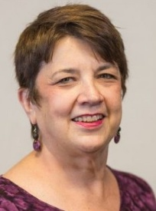


9:30am – 4:30pm | Tuesday 23 June


Easts Leagues Club, Jack Aitken Room

40 Main Avenue, Coorparoo


Description
Friendships. Being known. Being part of community. For many people with disability, these things are still missing. So how do we support real friendships to happen?
This workshop presented by Dr Angela Amado focuses on building authentic and lasting connections between people with disability and community members.

What will you learn?
- Ways to connect people with disabilities with community members and groups
- The role of workers and others as community connectors
- How to support relationships to grow and last overtime

Register now to secure your place or visit
cru.org.au/events/upcoming-events/

Please contact CRU if you need assistance to attend.
This event is supported by a Peer Support and Capacity Building (PSCB) grant for the NDIS
About the Presenter:
Dr Angela Amado has over 40 years’ experience supporting people with intellectual disability to build real relationships and connections in the community. She is internationally recognised for her work on inclusion, community membership, and building relationships, including her widely used publications on friendships. She has delivered training across the United States, Canada, Australia and Europe.


Tickets $10 - $50 people with disability and family members
$100 workers, friends & allies

Registrations Essential
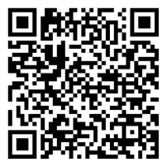
For more details & tickets visit www.cru.org.au/events/
upcoming-events

