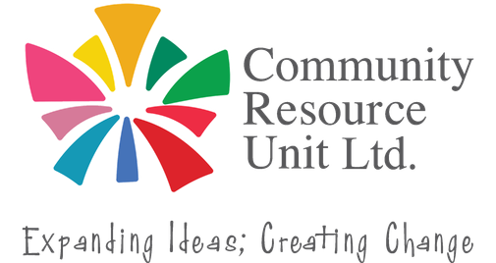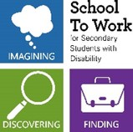

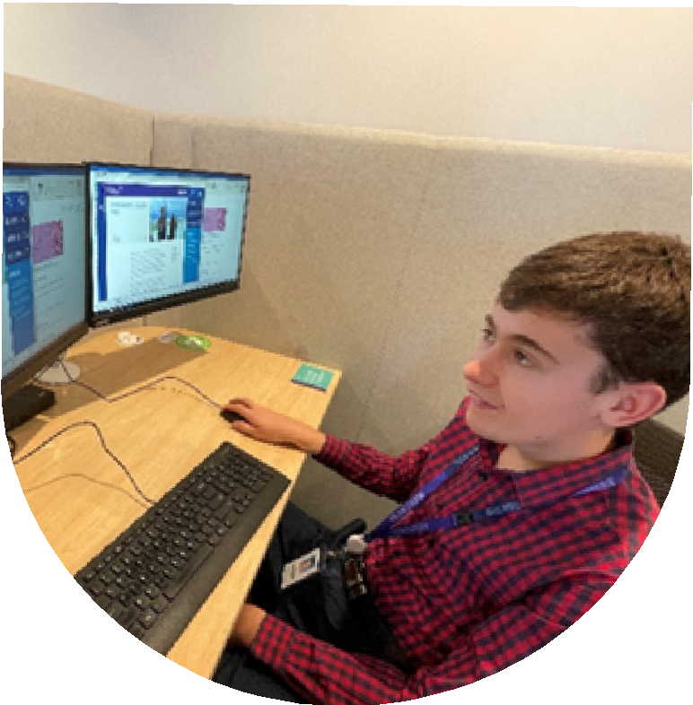
A Real Job or Just Filling in Time?
How Social Role Valorisation can help
Every young person deserves to get a job they love. Societal attitudes and low expectations around disability present an unfair barrier to young people.

Social Role Valorisation (SRV) explains why such barriers exist, what can be done to influence attitudes and expectations, and how family members and supporters can assist young people with disability into real jobs.

Who Should Attend?
If you are a parent or supporter of a young person with disability who wants to see them find real work that they enjoy, then this session is for you.

This webinar will cover:
Key concepts of Social Role Valorisation (SRV) How expectations influence employment opportunities
Being alert to roles as a path to meaningful work
This live webinar will include a Q&A.

About the Presenters:
This webinar will be presented by Lindie Brengman (accredited ASRVA co-teacher) and will also feature pre-recorded video excerpts by Jane Sherwin, one of only two senior trainers in Social Role Valorisation (SRV) in Australia (now retired).
Register your tickets now.

Register now to secure your place or visit cru.org.au/events/upcoming-events/
Please contact CRU if you need assistance at attend.
 Email: cru@cru.org.au




 Phone: (07) 3844 2211

Website: www.cru.org.au

Thursday 17 September
10am -11:30am
Online via Zoom
No cost, registration essential.
RSVP Mon 14 Sept


This webinar is Funded by the Department of Health, Disability and Aging (DHDA).

