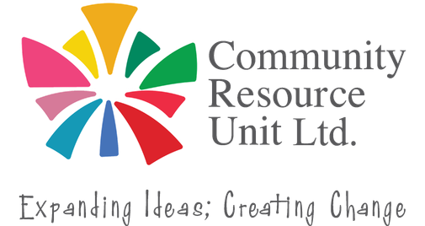


An Introduction to Sensory Awareness and Movement Differences
Before we can thrive at school or work, or in friendships and relationships, we all need to have our fundamental needs met. If we don’t understand or can’t express those needs it can impact everything else in our life.

Sensory awareness and movement differences can help to explain previously misunderstood needs. This highly interactive workshop is full of real-life examples and scenarios, and it will leave you with practical accommodations, strategies and ideas you can apply for yourself, a family member or a person you support.


This workshop covers:
Wednesday 14 October 2026 9:00am to 4:30pm
Crystalbrook Riley Hotel 131/141 Esplanade CAIRNS
$10 - $50 for people with disability and family members.
$100 workers, friends and allies.
RSVP date 30 September 2026
- Foundational knowledge in Sensory Awareness and Movement differences
- The functions and physiology of the senses
- Sensory Integration Dysfunction, and related disorders
- Common difficulties for people with hypo/hyper arousal of each sense
- Practical sensory experiences; understanding own preferences
- How sensory differences relate to anxiety and behaviour

The topic will be relevant for many people, including Autistic people and others with neurological differences, and their families and supporters.

About the Presenter:
Joyce-Lyn Smith has over 25 years of professional experience supporting people with complex support needs, and has previously worked in the Intensive Behaviour Support Team with the Queensland government.
Register now to secure your place cru.org.au/events/upcoming-events/

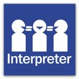

Please contact CRU if you need assistance to attend.
Email: cru@cru.org.au






Phone: (07) 3844 2211

Website: cru.org.au

This event is supported by funding from the Australian Government Department of Health, Disability and Ageing.

