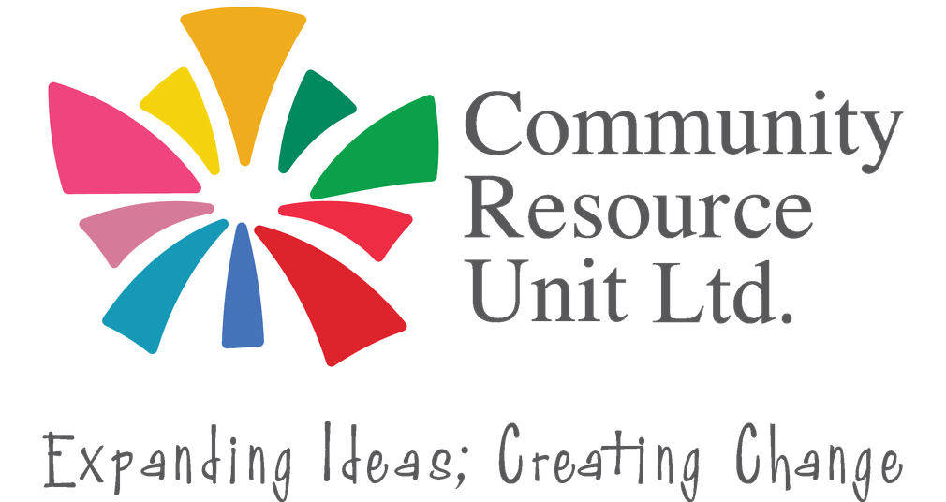

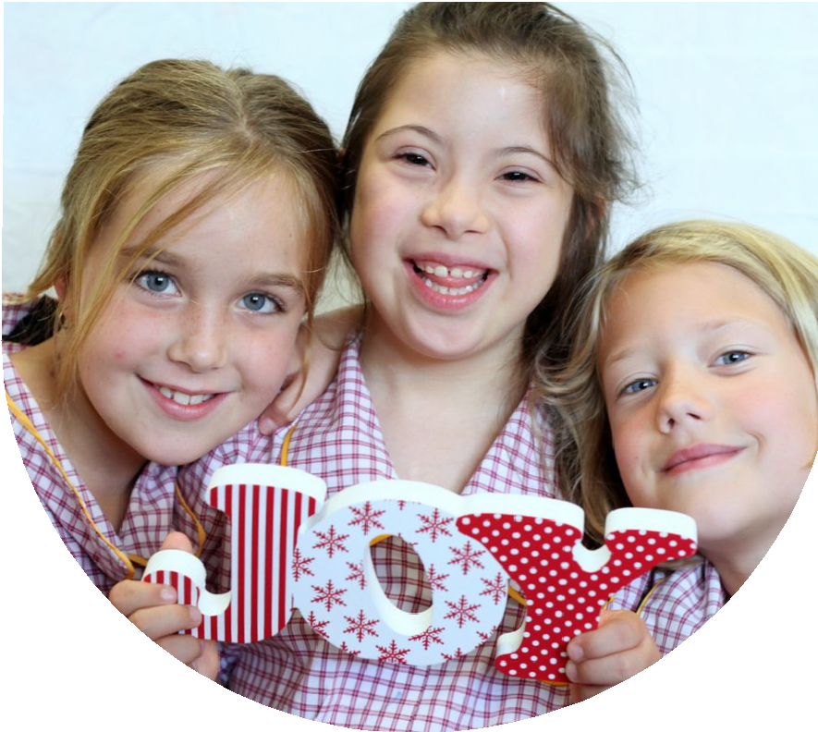
Inclusion as a way of life:
What you can do to ensure your child with disability is in the everyday places

This fully-funded (free to families) face-to-face workshop will be delivered by CRU facilitators passionate about inclusive lives for children with disability.

Every child should feel they belong, and be known and valued, not only by their family, but also by their wider community. It is common though for families with children with disability to worry this may not happen automatically for their child. They may wonder what, if anything, they can do about this.
Wednesday 9 September 2026
9:30am - 2:00pm
Moranbah Youth and Community Centre
2 Appleton Street
MORANBAH 4744
There is no cost for this workshop. Registration is essential.

This workshop will cover:
- What genuine inclusion looks like and why it matters
- Identifying welcoming people and places in your local community
- Being confident in seizing opportunities for belonging in everyday places
- Strategies that families have found helpful in building an inclusive life for their child

 This is a collaboration with the MDSS Neighbourhood Centre.

Register now to learn about genuine inclusion.

Register now to secure your place or visit cru.org.au/events/upcoming-events/
Please contact CRU if you need assistance at attend.
 Email: cru@cru.org.au




 Phone: (07) 3844 2211

Website: www.cru.org.au

About the Presenters:

Ainsley is a parent of a young adult son with disability and Bronwyn has
supported 100s of families across Queensland to build inclusive lives for
their family member with disability. They bring to this workshop their combined
experience and passion for advocating for children’s inclusion in the ‘mainstream’ places in their communities.

In their time working with Community Resource Unit (CRU) they have delivered many workshops statewide and have had hundreds of conversations with parents/carers of children with disability about building their belonging in their local communities.

Ainsley and Bronwyn believe it is never too early, and never too late, for a family to develop a vision of inclusion for their child, and to take steps towards achievement of this vision.

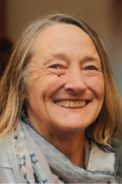

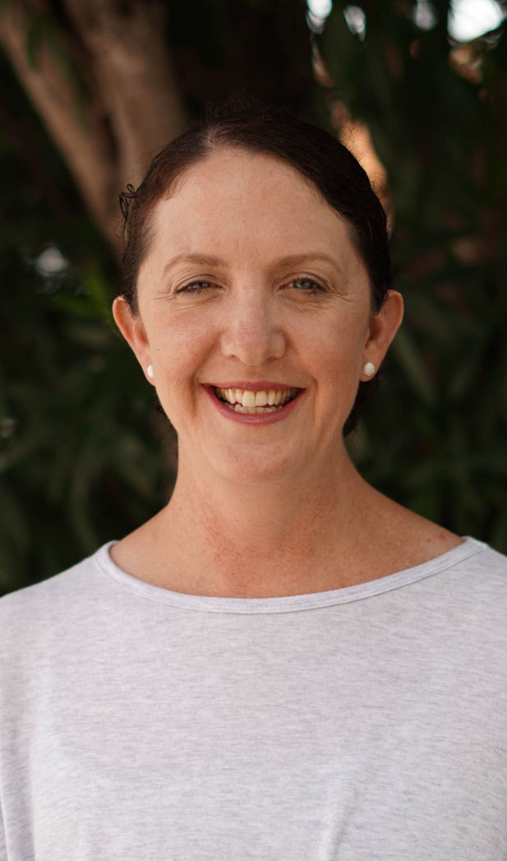

Register now!

Register now to secure your place or visit cru.org.au/events/upcoming-events/
Please contact CRU if you need assistance at attend.
Email: cru@cru.org.au
Phone: (07) 3844 2211
Website: www.cru.org.au

