CRU Workshop: Seven Steps to Self-Direction - Building right relationships between people living with disability, their families, committed friends and support workers.

Wednesday 7th November 2018 in Rockhampton

About the Workshop
- How have other people made self-management work? This one-day workshop explores a practical, values-based framework of self-direction, and how to develop supports that work respectfully and constructively together.
- The seven steps provide a simple, helpful guide that can be worked through, or started at any step. This workshop draws on the resource developed by Griffith University (Dr Margaret Ward) as part of the NDS Innovative Workforce Fund Project.
- Self-direction has been found to give greater choice and control, and more effective and flexible use of available formal and freely-given support. Good support requires the right people to provide the right level of support at the right time.
- There are some preconditions that make good support in self-directed arrangements more likely to happen. This seven step approach takes participants from starting with the person through to problem solving and checking for resilience.

Who should attend?
- This workshop is for people with disability, their families, supporters and workers who are involved in a self-directed arrangement who want it to work as well as possible, and for people interested in moving to a person-centred, self-directed arrangement. It works best if the person comes with their family and supporters.

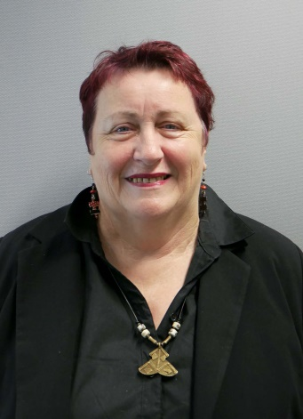
About the Presenter
Figure 1 photo of presenter Sharon Bourke
- Sharon Bourke currently works as a Professional Development Consultant and has presented many Participant Readiness sessions for CRU over the past three years. She has worked in various roles, including managing individualised support agencies, advocacy, workshop facilitation and planning.
- In partnership with her youngest son Dan, Sharon has chosen to self-direct funds that support him.

Event and Venue Details

Date and Time
- Saturday 13th October 2018.
- Please arrive at 9am for a 9:30am start.
- The workshop runs from 9:30am to 4:30pm.
- Sign in from 9:00am.

Venue details
- The venue is the Frenchville Sports Club.
- 105 Clifton Street, Berserker.
- The workshop will be in the Keppel Room.
- You can contact the venue directly on 4932 6800.

Cost
- For people with a disability and family members: $65.
- Full fee: $150.
- A light lunch and refreshments are included in the price.

Purchase Tickets
- Please register and book your tickets through the CRU Eventbrite link https://7stepsrockhampton.eventbrite.com.au

RSVP
- Registrations close on Monday 22nd October 2018.
- If you wish to register after the registration date has closed, please contact CRU on 3844 2211. We may be able to offer you a place, but it may be more difficult for us to respond to dietary requirements or other support needs.

Cancellations:
- To view CRU's cancellation policy please visit this link: http://cru.org.au/about/policies/#cancellation

About Community Resource Unit Ltd.
- CRU has a 30 year track record of working across Queensland to help people with a disability take control of their lives and take their place in their community.

Contact Community Resource Unit Ltd.
- Phone: 07 3844 2211
- Email: cru@cru.org.au
- Website: www.cru.org.au
- Address: Level 2, 43 Peel Street. South Brisbane. Queensland.

